TypeScript – Part 6

# TypeScript for Every Part of Your Stack

If we use Prisma, we can achieve the database type safety and can also use same generated model in the backend API as-well-as in the frontend.

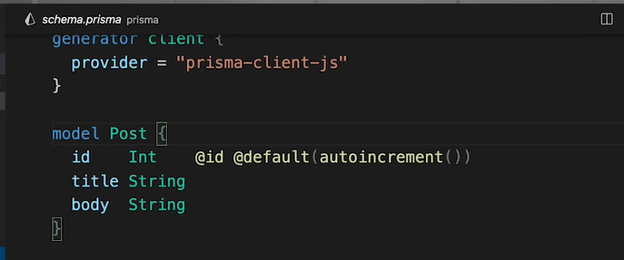

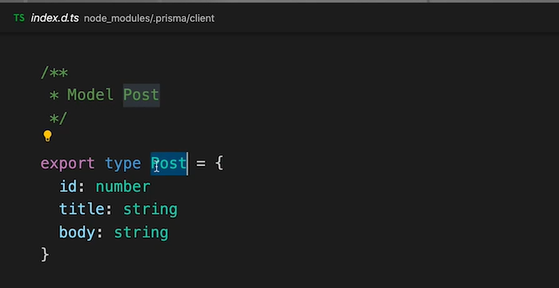

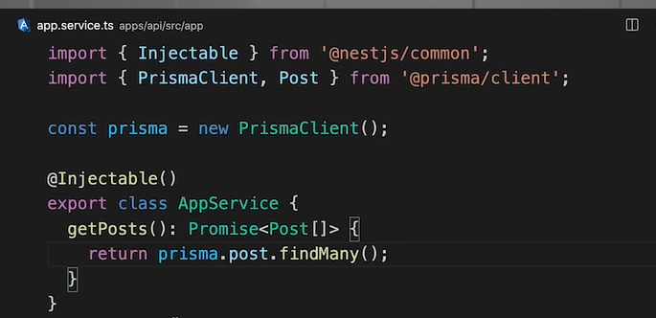

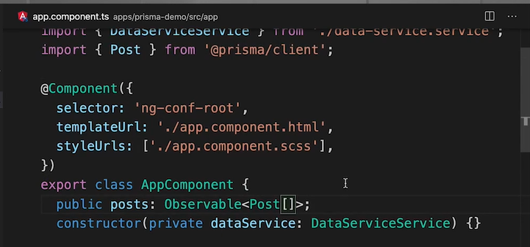

# Creating and Using Generics in TypeScript

Generics are not supported in Javascript, due to this it is a feature of Typescript. It is a reusable code that works with multiple types. It may be function, interfaces or classes, it uses a type (<T>) parameter.

Generic constraints increase practicality and generic function type add flexibility.

We can’t use generic with static functions or classes as generic gets applied on the instances.

Generic classes offer type-safe versality (with or without implementing an interface).

# Configuring, Compiling, and Debugging TypeScript Projects

Different versions of typescript can be installed along with a global version.

We should refer our local typescript install from npm script like to get the version number tsc -v.

Possible changes and tasks for watch files –

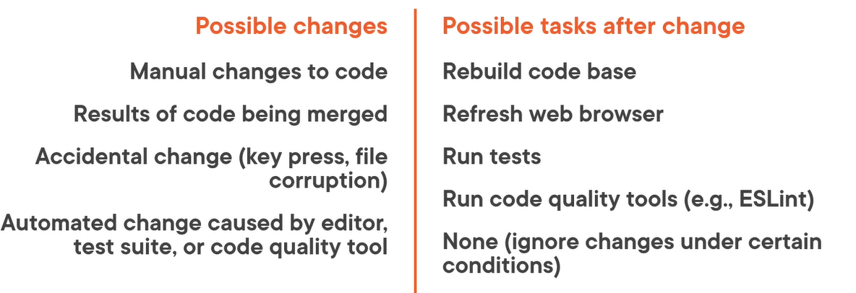

Project references separate application into logical silos. Then we can also customize build steps for each sub-project. The sub-projects are own separate typescript applications.

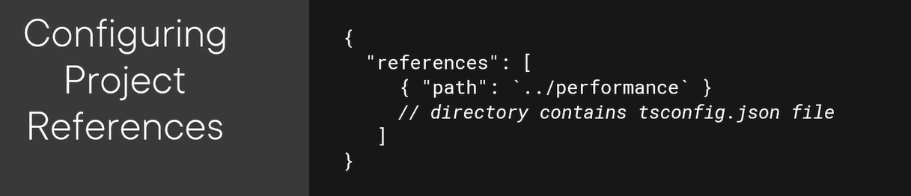

A source map is a tool for coupling between typescript code with generated code.

# TypeScript Fundamentals

It is like a JavaScript, with guard rails. An interface defines the shape of data. It is like a mold used to create baked goods such as muffins. It drives consistency across the objects.

Unlike Interface, Type can also be used to represent primary types of not just object like data structure.

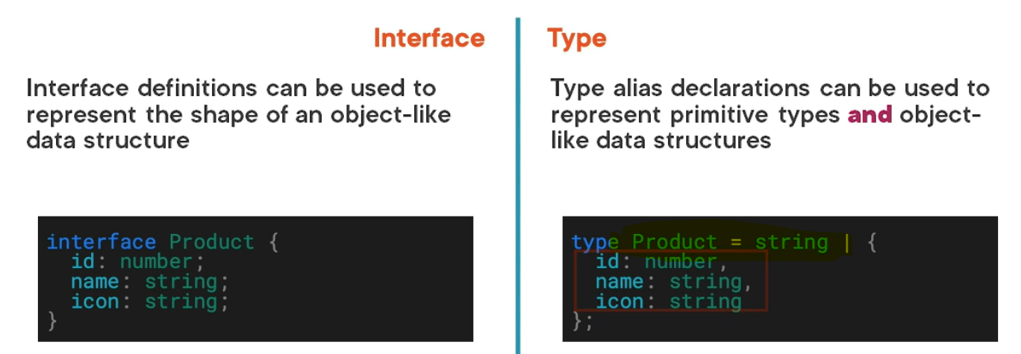

A class encapsulates data and code, it acts as a template that can used to create object instances.

We can also create generic interface like below –

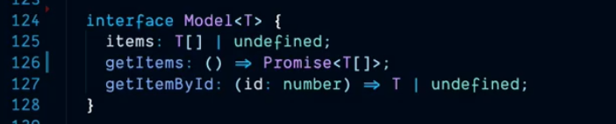

# JavaScript: Using Arrays (Interactive)

Arrays can hold lots of stuff – strings, values, variables, other arrays and combination of all. Below array example also called 2 dimensional array.

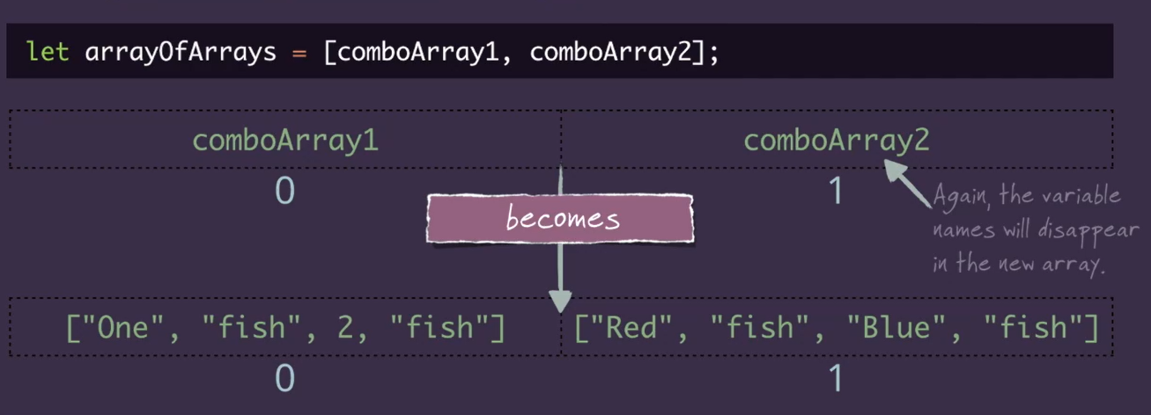

# JavaScript: Using alert, confirm and prompt (Interactive)

Alert() – sends a message to the user in a small pop-up window.

Confirm() – asks user for consent to forward with an action.

Prompt() – sends a message and retrieves an entry from the user.

The ‘typeof null’ will return generic ‘object’ value.

# Javascript: Using Function Expressions (Interactive)

Function expression – functions on the fly. Building functions within code execution rather than at program load time.

Note – the second function will get load only when our program reaches that line of code. It is also useful to pass that function into another function as a parameter.

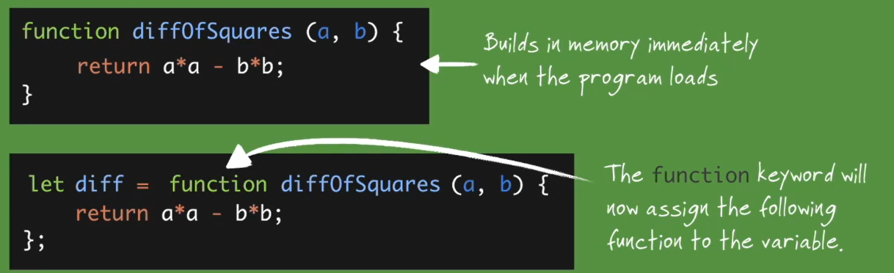

Anonymous function – no need for the naming the function a second time.

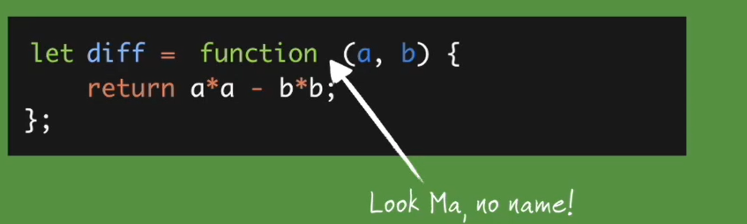

The map() method on a array works like a loop that applies a function to each array index, like below code -

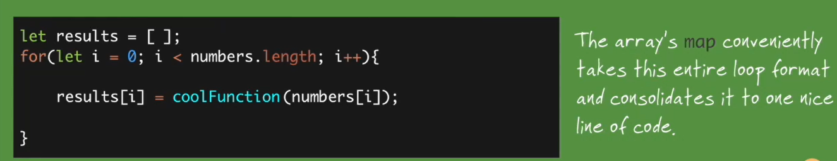

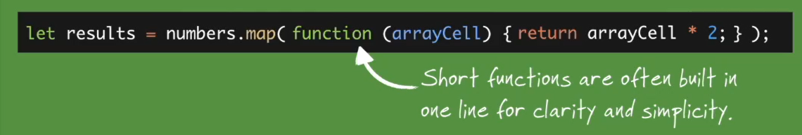

The pop, push and shift method will automatically modify the array’s length as they don’t assign the undefined to the deleted array element.

We can also return function from a function as functions can be treated as expression, they can also be returned like values.

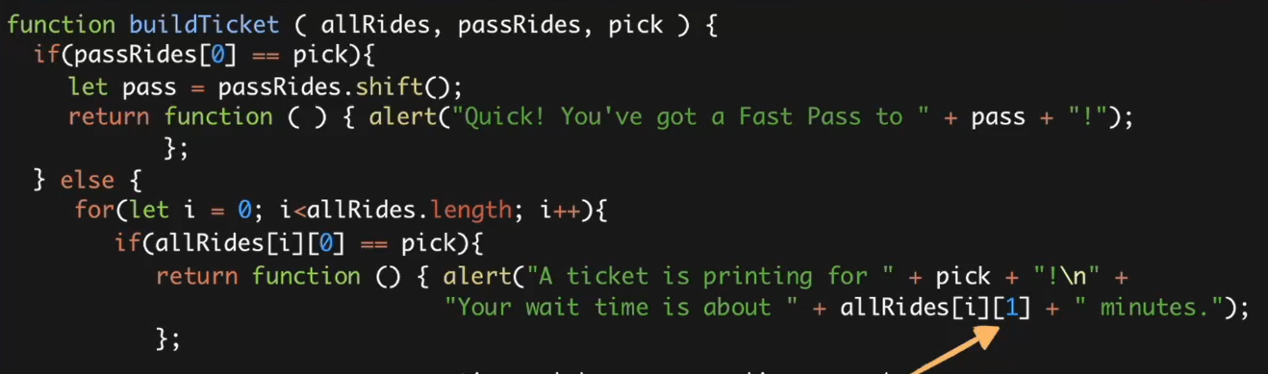

By using an immediately-invoked function, we can call returning function instantly instead of variable storage.

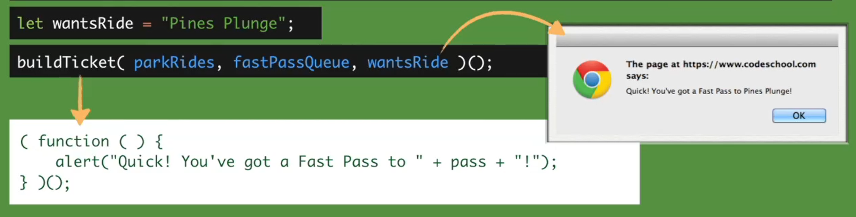

# JavaScript: Using Function Declarations (Interactive)

A function ‘does something’ step-by-step that we need to do repeatedly. It provides usefulness through reusability.

Function parameters can also be expressions, which the function will resolve before starting –

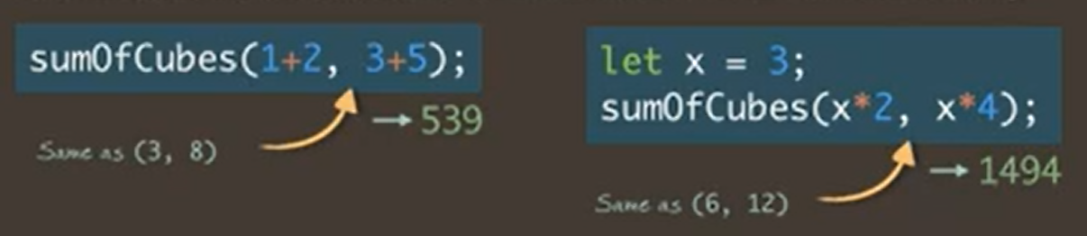

Functions crate a new scope, variables declared in function STAY in the function.

# JavaScript: Using Conditionals (Interactive)

Use else-if syntax when two conditions just isn’t enough. By using nested conditionals, we can split results for a single condition.

# JavaScript: Using JavaScript with HTML Documents (Interactive)

[NA]

# JavaScript: Using Closures (Interactive)

A closure wraps up an entire environment, binding necessary variable from other scope. It is unlike a function’s local variables as they aren’t available once the function’s scope is closed.

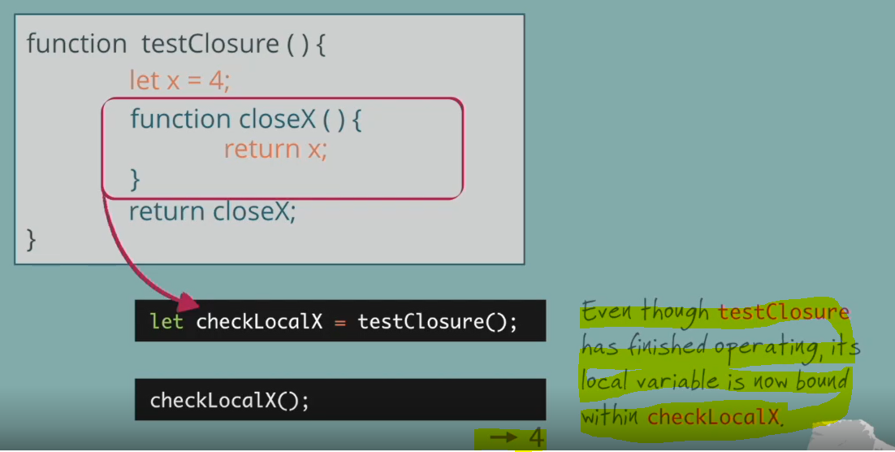

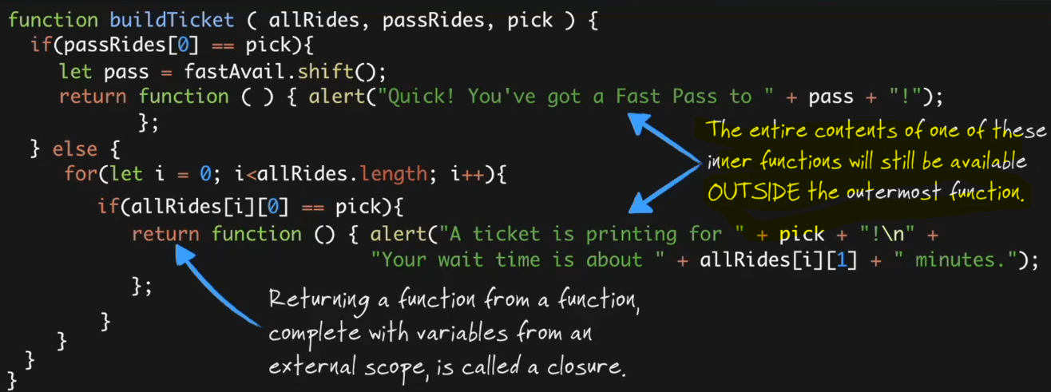

Closures are very useful in creating function ‘construction zones’, a closure can make the creation of very similar functions ultra-efficient. We should aware that bound variables won’t be evident in the stored function, examining the contents of our new variables doesn’t reveal closures. Like below –

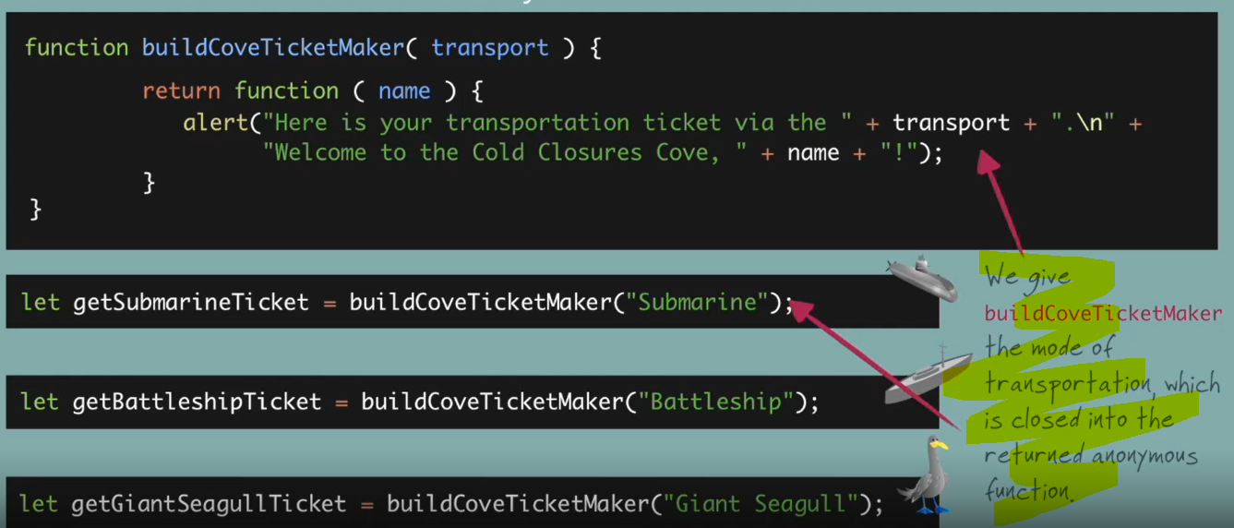

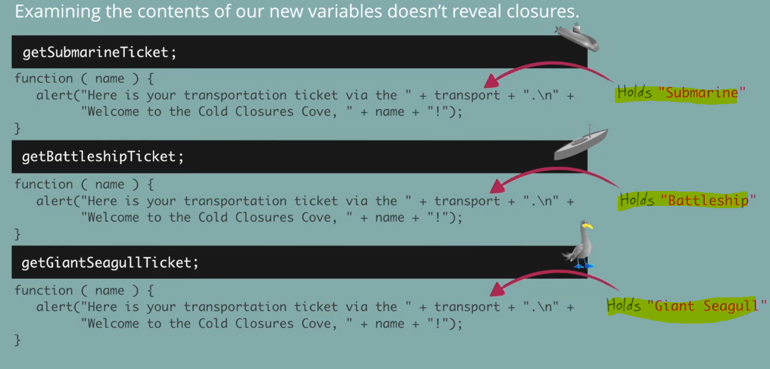

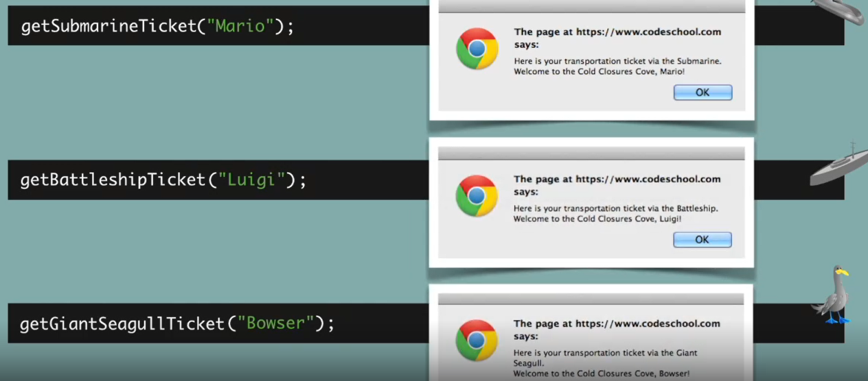

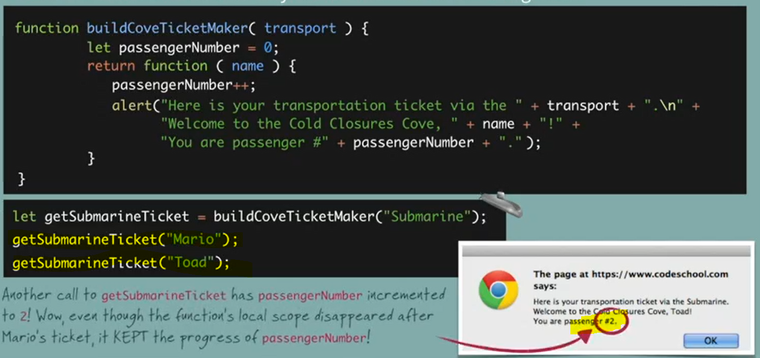

# JavaScript: Using While and For Loops (Interactive)

Loops allow us to have code executed repeatedly without extra typing.

# JavaScript: Using Variables and Working with Numbers and Strings (Interactive)

Order of operations – PEMDAS.

Strings is a way by which javascript stores and processes flat text.

We can use special characters inside strings but it needs backslash notation like below –

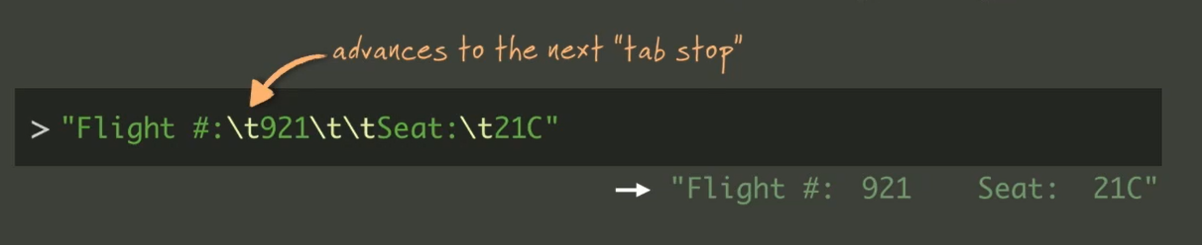

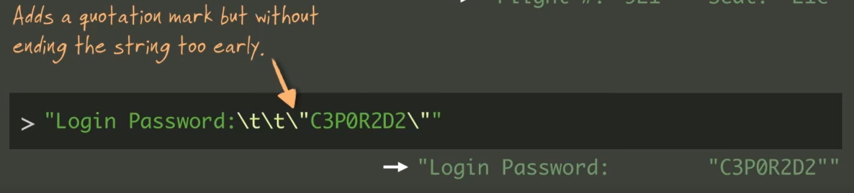

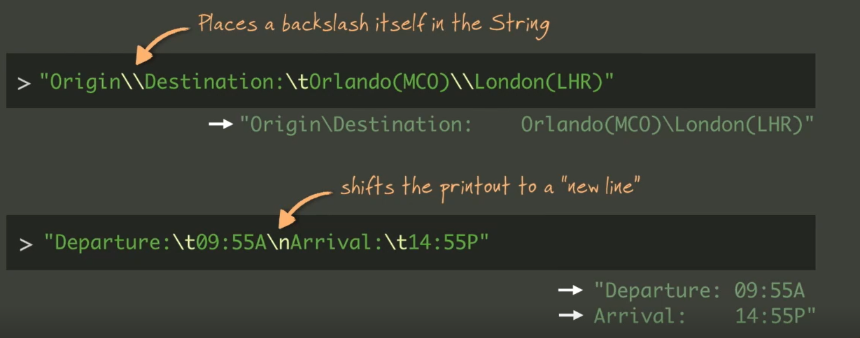

String comparison – javascript is case sensitive while comparing string values –

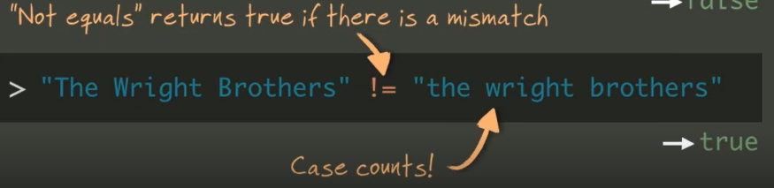

Variables help in organizing data, they create a versatile message out of flexible pieces.

# JavaScript ES2015: Additions and Changes to ES5 (Interactive)

Using let in ‘for’ loops – with let, there is no sharing I for loops, a new is created on each iteration.

We should replace magic numbers with constants and by using the const keyword, it creates read-only named constants.



The REST parameter is used in function definition and the Spread operator is used in function invocations.

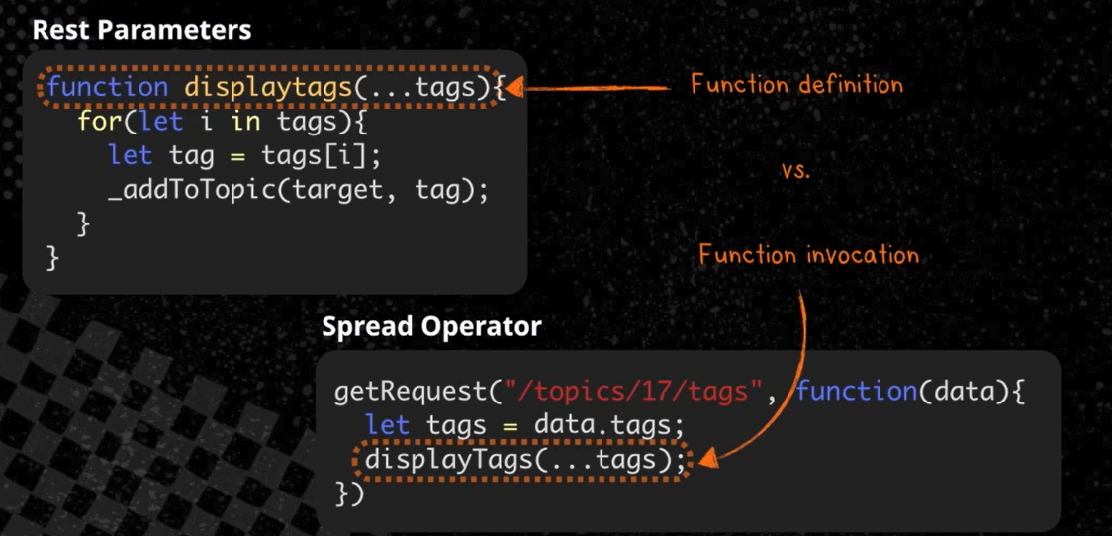

Arrow function have lexical binding scope, it means they get bind to the scope where they are defined, not where there are run.

By using Object.assign, the source object remain unchanged, the target object is modified and used as return value. In case of duplicate properties on source objects, the value from the last object on the chain always prevails.

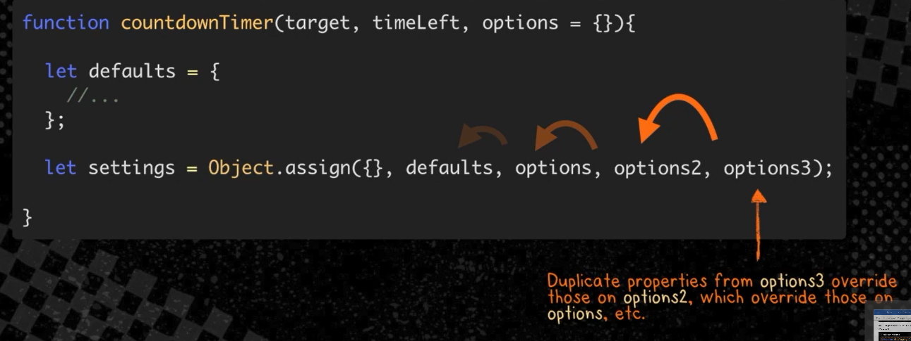

The WeakMap is a type of Map where only objects can be passed as keys. Primitive data types such as strings, numbers, etc. are not allowed. Also WeakMap can be iterated but these are good with memory, individual entries in a WeakMap can be garbage collected.

We should use Sets data type as Arrays don’t enforce uniqueness of items and duplicate entries are allowed. In Sets object stores unique value of any type, whether primitive value of object reference. It will ignore the duplicate values –

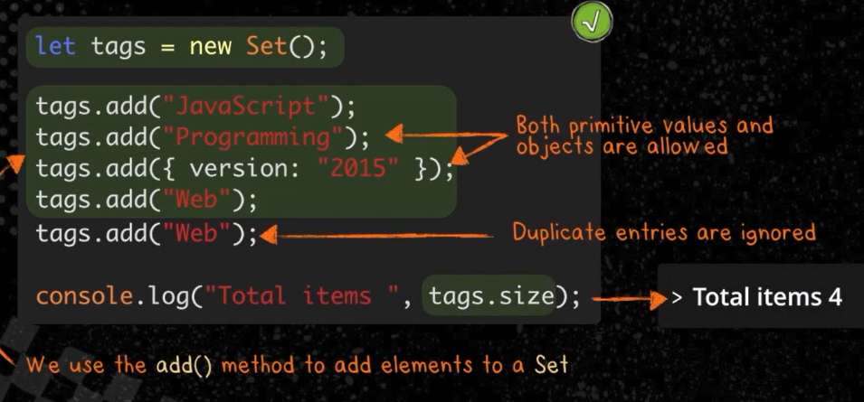

Iterables return an iterator object. This object knows how to access items from a collection 1 at a time, while keeping track of its current position within the same sequence.

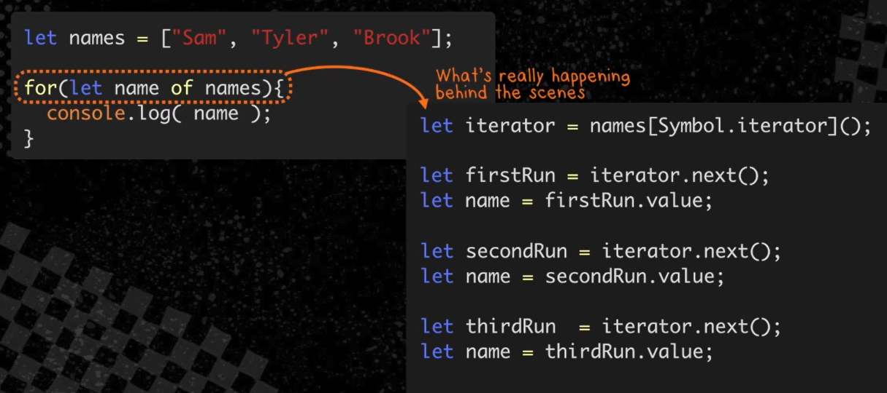

Generator functions – the function * declaration define generator functions. These are special functions from which we can use the yield keyword to return iterator objects. Each time yield is called, our function returns a new iterator object and then pauses until it is called again.

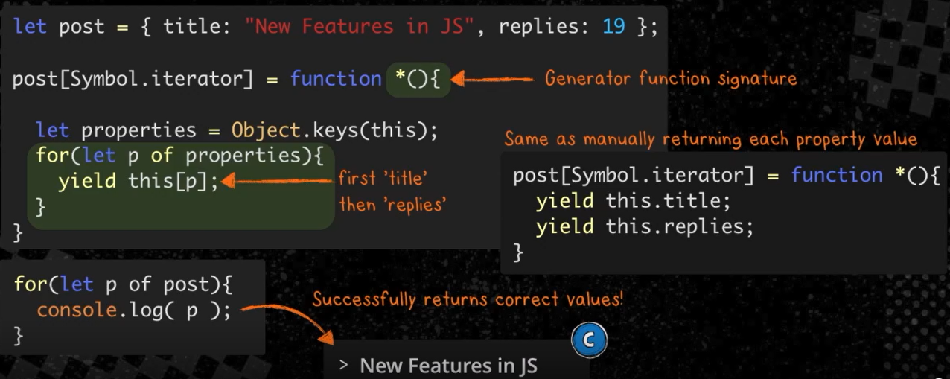

# JavaScript Proxies and Reflection

Proxies and reflection are both forms of meta programming generally to know information about itself or for a program to control how is executing while it is executing other programs.

Reflection is getting information about the program and proxy is changing how the program execute during execution.

Proxy object sits between other code and target object.

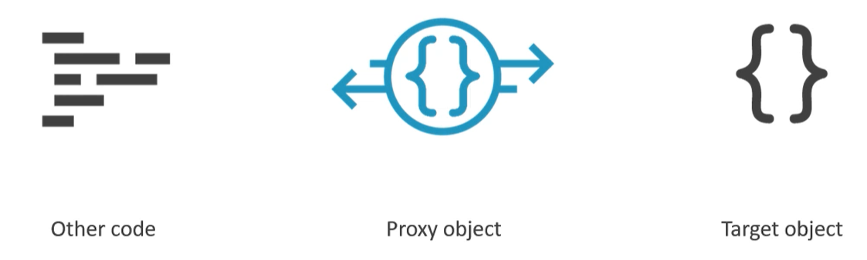

Proxy traps are function that we can add to handle operations on the proxy

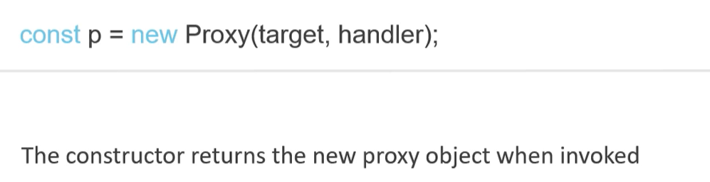

It will have three new methods on it –

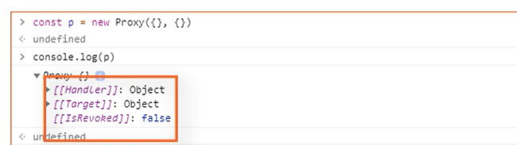

The target of the proxy cannot be changed once set.

Common internal methods on object –

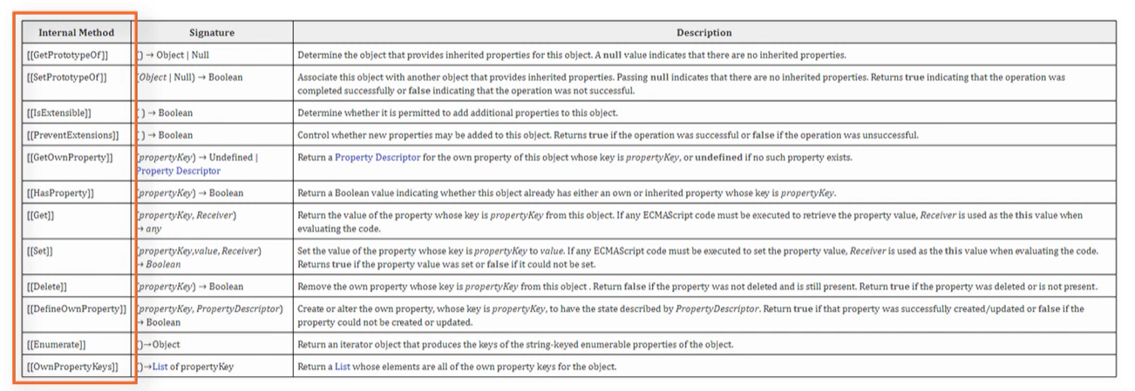

With proxy traps we can handle operations in any way we like, all above internal methods can be used for traps. Like below we are using get() method, and which will now console log instead of property value –

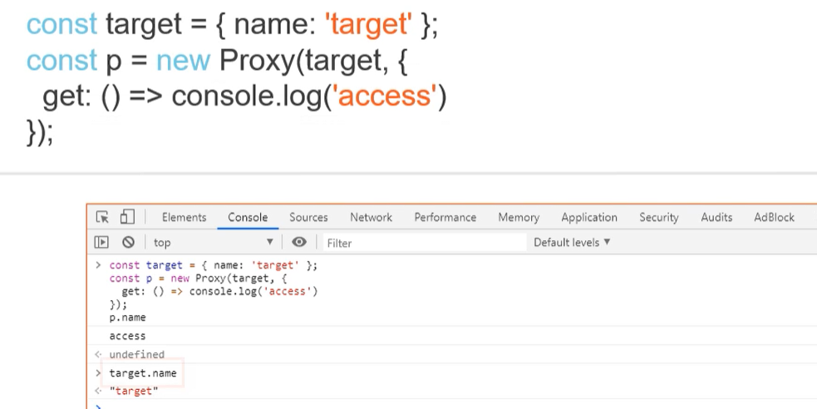

To create a short-lived proxy, use revocable while creating the proxy.

Proxies are slower than regular object.

Revocable proxies allow the system to recover resources – use in very large applications with lots of data.

We can use ‘get’ trap to check if someone has access some specific property or not, like emulating private property.

Using ‘set’ trap to check the value of property while setting and check validation –

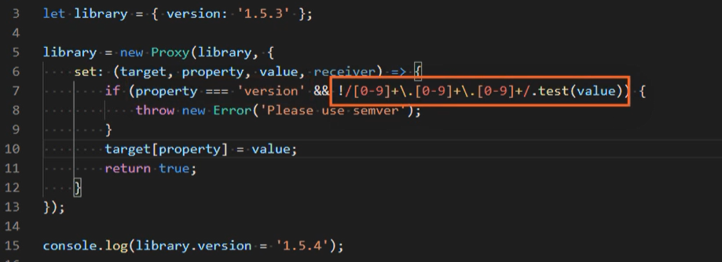

Real scenario – we can make server call, whenever we set any property in an object to auto sync –

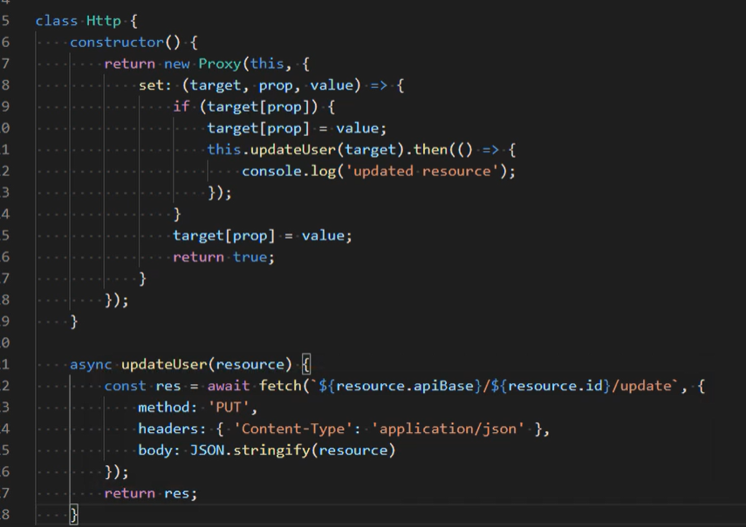

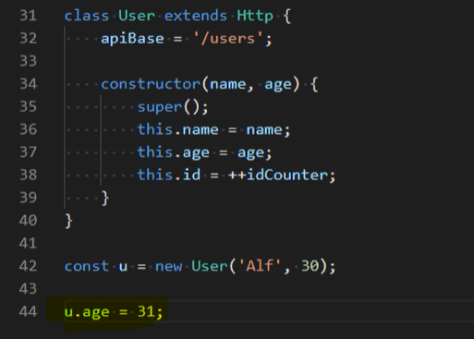

The apply trap can be used to trap function calls. The construct handler traps the new operator. The getPrototypeOf and setPrototypeOf traps are triggered when getting or setting the prototype of proxied object. isExtensible and preventExtensions handlers are used to trap methods of the same name from the object constructor, the defineProperty and getOwnPropertyDescriptor handlers can be used to work with the objet.defineProperty and object.getOwnPropertyDescriptor methods.

The reflect object is a built-in global object that contains only static methods, it has same method names like proxy API. We can use reflect object inside proxy handlers or anywhere else.

Benefits of using reflect API is that object.defineProperty method returns an object while reflect.defineProperty returns a Boolean so reflect requires less error handling. It also makes forwarding operations to the target object easier.

Instead of target, we can use Reflect which is the same thing –

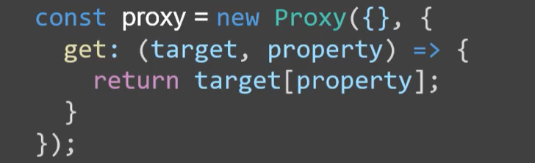

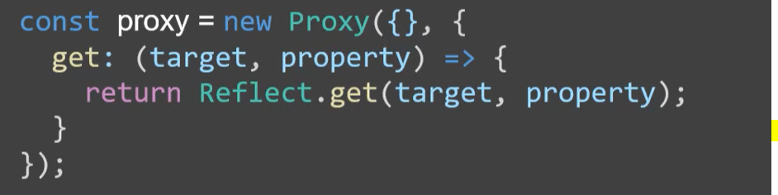

Some of the methods of Reflect API are more convenient like instead of delete object.property we can use Reflect.deleteProperty(target, property) like a function manner, or use Reflect.apply, etc.

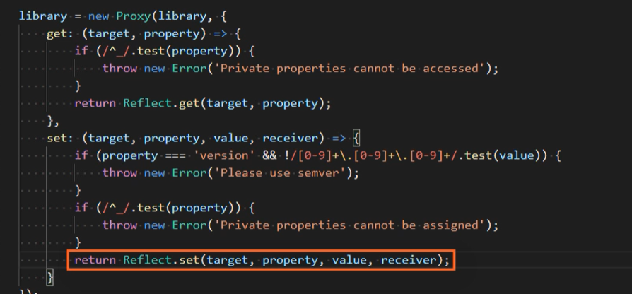

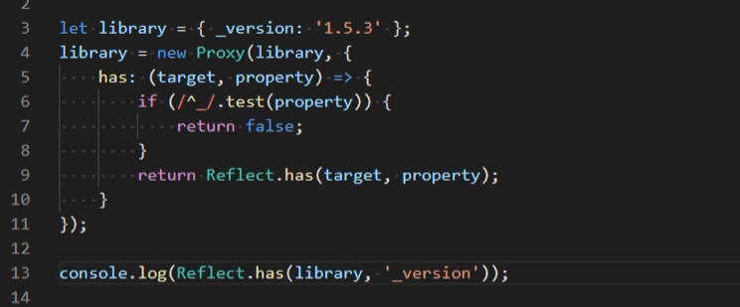

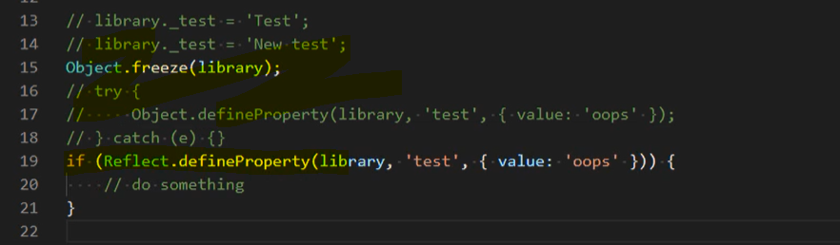

# [ultimatecourses.com] TypeScript Basics

Typescript also support new features of ECMAScript and other features which even didn’t introduced yet in ECMAScript like interface.

When using the typescript types we should not use the uppercase javascript types, we should be using the typescript types i.e. lowercase versions of them – like number instead of the Number.

The void type is not exist in javascript language.

We can use ‘never’ type when a function is not going to return any value like if that function throw an error.

To define different types of data in an array we can use tuple to enforce king of fixed structure instead of a loosely one. So, if use type as [string, number, boolean] then the values should match the same order type unlike union type.

We can use type aliases to assign any kind of types to it, it is kind of temporary variable which we might want to keep and simply assign wherever need to –

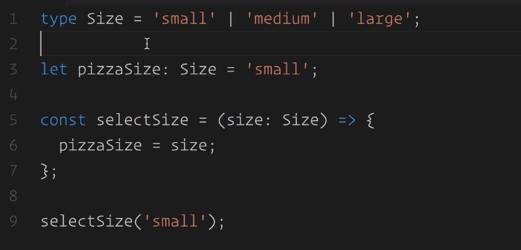

Use type assertions when we wanted to make sure that we are dealing with correct type-set like checking the type after converting a JSON stringify value to JS object –

For more complex data structure we should use interface instead of using the ‘type’. It will also enforce the type/contract more strictly by showing error if pass unrelated signature.

Use protected access specified if we wanted to use the private member of a class from which we have inherited the current class.

We cannot add a property to interface declaration if it is private or protected. Only public properties can be added to the interface signature.

The get the timestamp of a date use + new Date(); method. We generally use for pure functions or utility functions.

The now() is a static method on Date class.

# TypeScript 4 In-Depth

We can also do function overloading with TypeScript.

We have a new feature calls class expression –

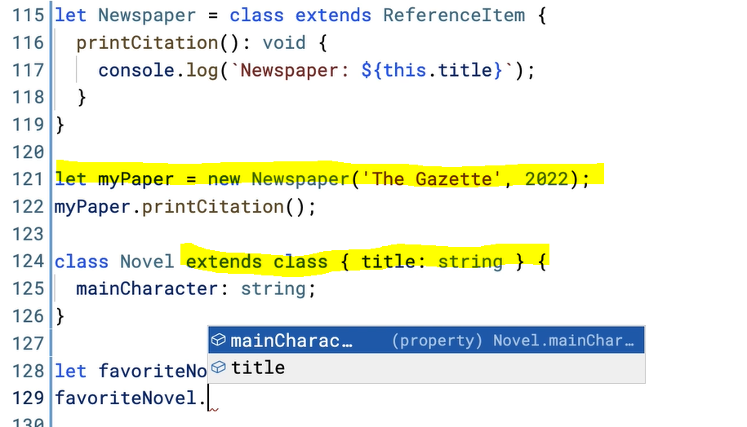

Module formats – es2015 syntax is in-built one which TypeScript adapted from JavaScript. Earlier ones were CommonJS, AMD (for browser), UMD, System JS formats.

# TypeScript 5 Fundamentals

Duck typing in JS –

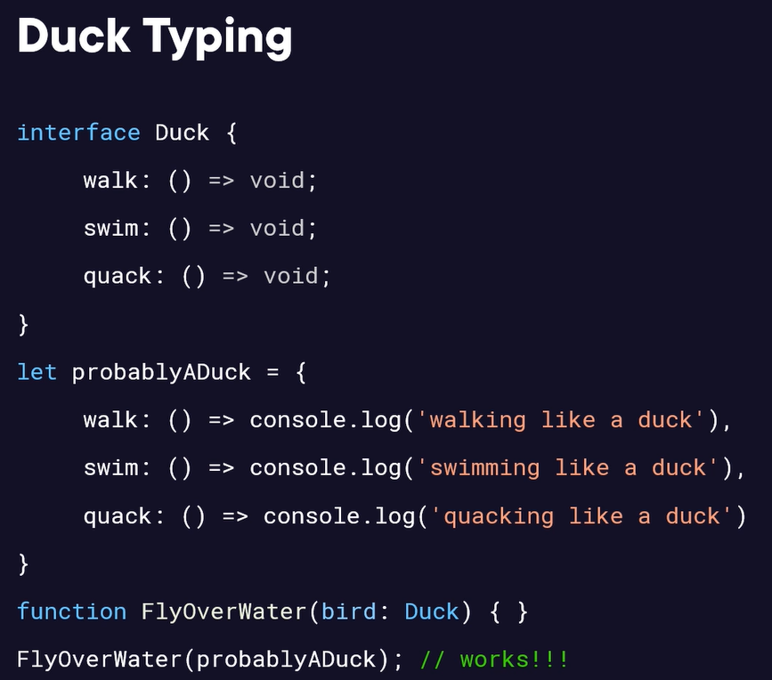

In typescript, there can be only one constructor function per class unlike other languages. For different constructor parameters we need to use the optional parameters feature instead of having multiple constructors.

The "in" operator in JavaScript validates prototype properties rather than object values. While "includes()" checks the array values directly, "in" only checks the prototype for available properties or methods. When to Use in - in is best suited for checking if a property or method exists on an object rather than its specific values. Some good uses include: Checking for object keys before accessing, Validating methods exist before calling, Iterating over all properties with a for/in loop. It's not ideal for checking array values directly. For that, use includes(), indexOf(), etc.

We can also use class expression like below –

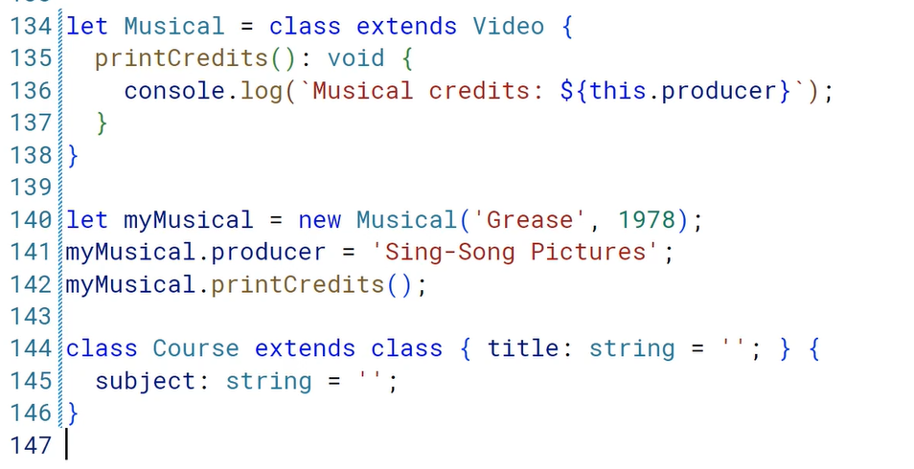

Modules promotes encapsulation, reusability and create higher-level abstractions.

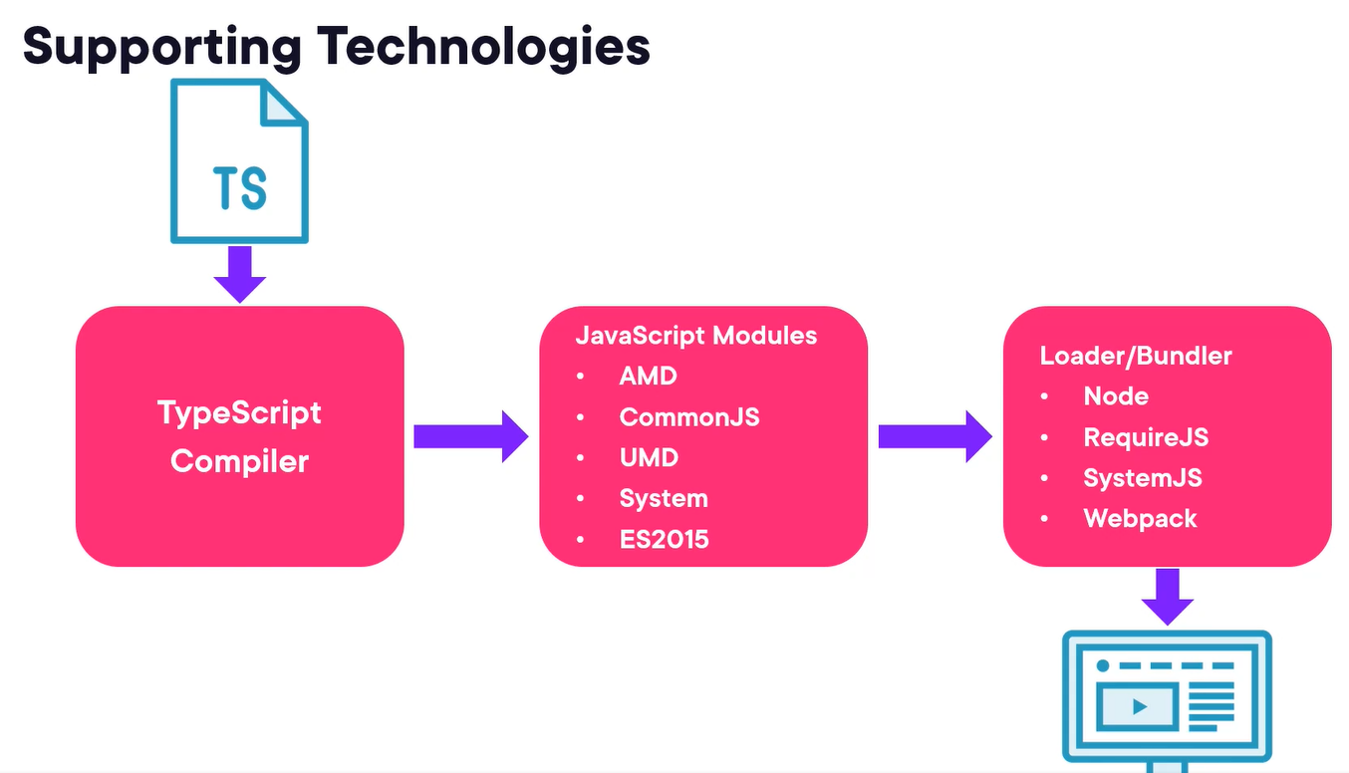

To import everything from a module, instead of importing it by specifying the items one by one, use below syntax –



As a best practice, we should use relative import references when referring to our own local modules, and use non-relative import references when referring to the 3rd party modules.

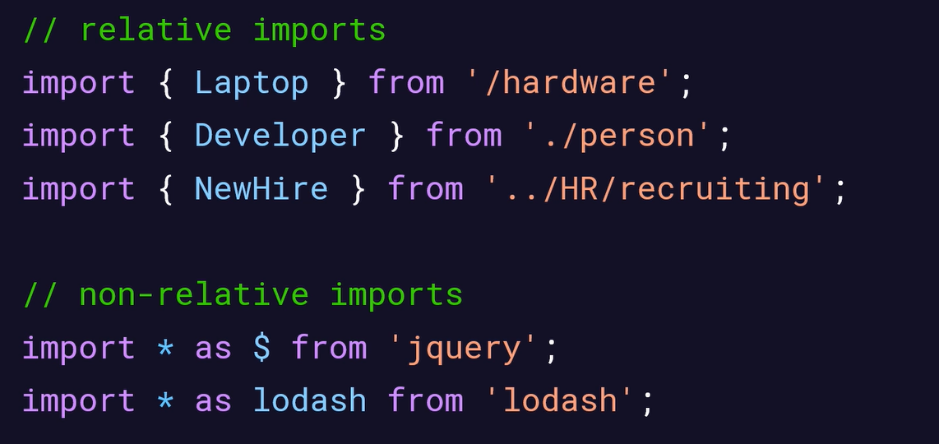

Decorators are function that is applied to other code. It is a form of metaprogramming. It can be applied to classes, methods, properties, fields, getters/setters.

# Transpiling and Polyfills for Extended JavaScript Support

JS version history –

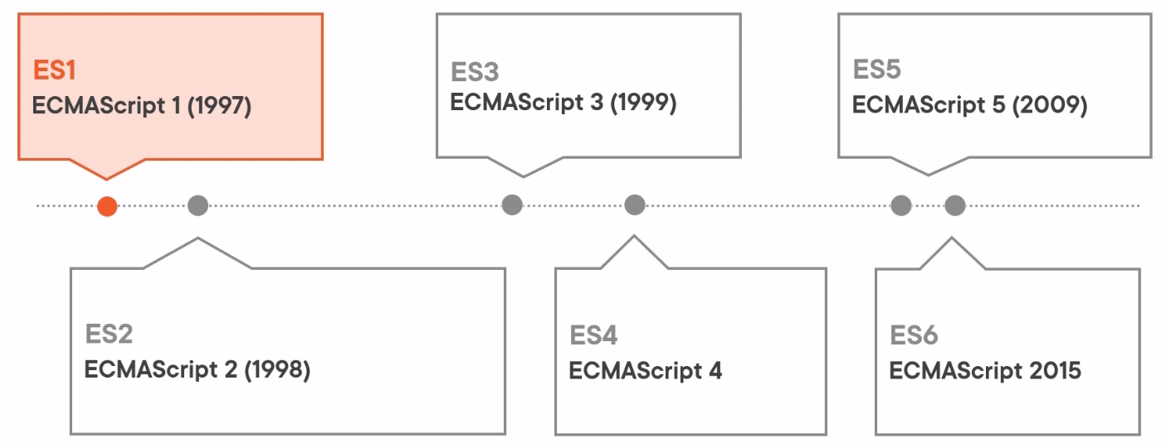

ES3 new features – strict equality, switch statement, try-catch block.

ES4 – never released as developer group never agreed on specifications.

ES5 – use strict, various array methods, JSON support (stringify and parse methods), getters/setters

ES6 features – arrow functions, classes, object destructuring, let & const and promises.

Compiler convert high level human readable code into lower level machine code. Transpilers transfer the code a language into another form of the same language. Transpiler also referred to as source to source compilers. This process converts one higher level language to another higher level language.

Why transpiler is needed –

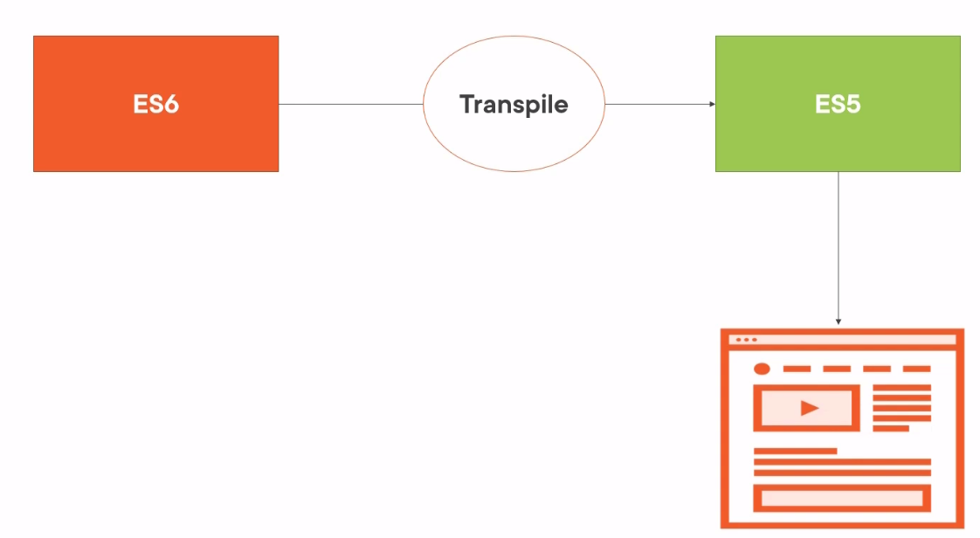

The core-js is polyfilling library. Some built-in functions are not included in all browsers or they take some time to implement these functions, for this we need polyfilling. It ensure websites can run correctly across all browsers. It also helps in support for deprecated features on newer browsers for older apps.

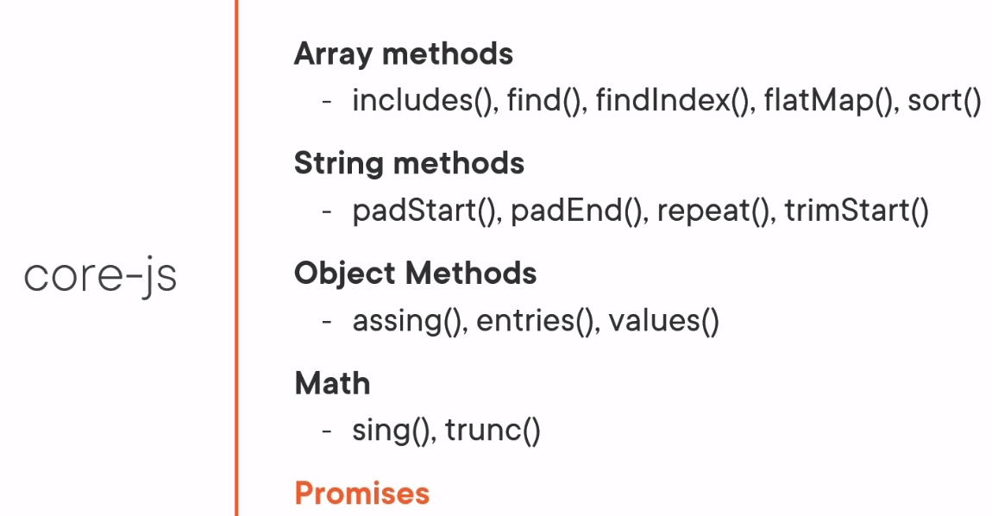

# Web Assembly Interaction with JavaScript

WebAssembly (Wasm) is a binary instruction format for a stack-based virtual machine. Wasm is designed as a portable compilation target for programming languages, enabling deployment on the web for client and server applications.

Web assembly can’t replace JS, in fact it is dependent on JS. JS is used as a host language to load and instantiate Wasm module in the browser. JS interacts with Wasm with import/export functions.

Creating a web assembly instance –

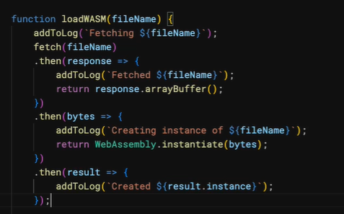

# JavaScript in the Browser

DOM

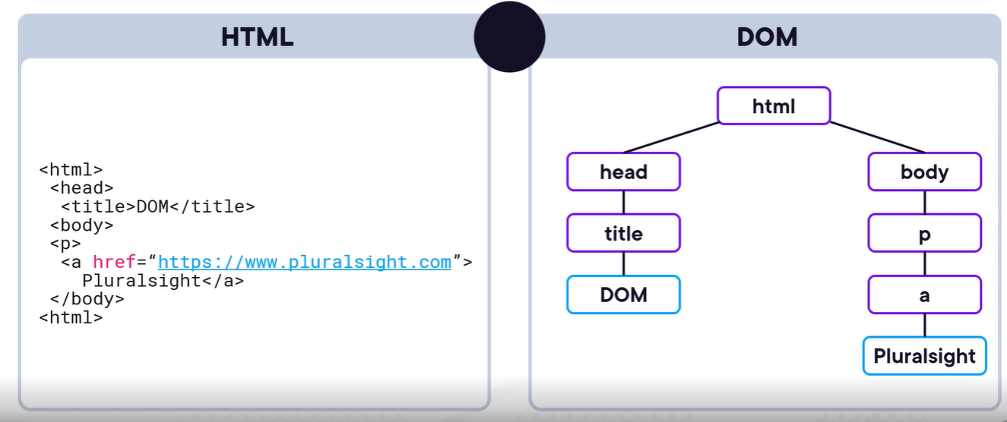

DOM version history –

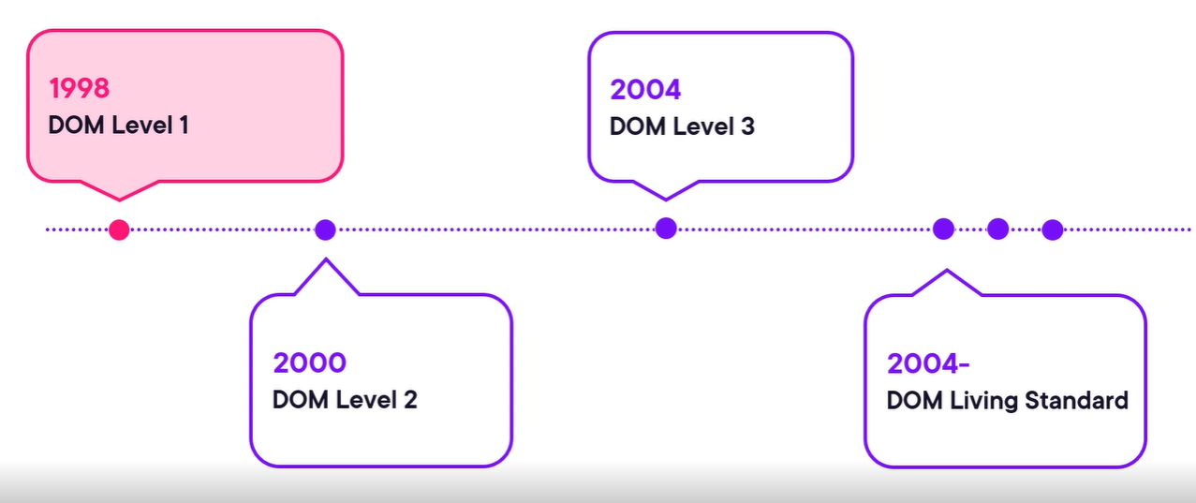

Node has attributes and properties like innerHTML is a property but not an attribute in DOM for HTML.

The el.classList.add() is the preferred way to manipulate the CSS –

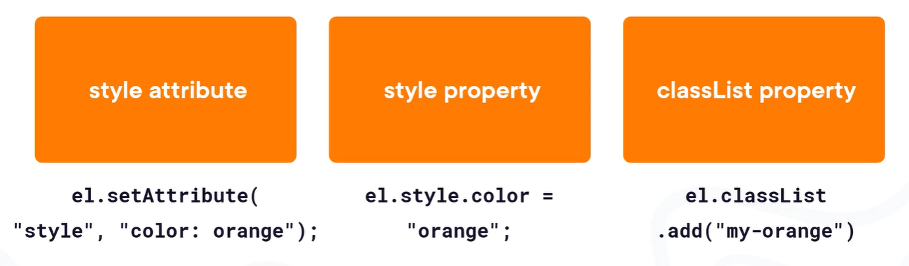

While removing a node from DOM element we should use modern approach –

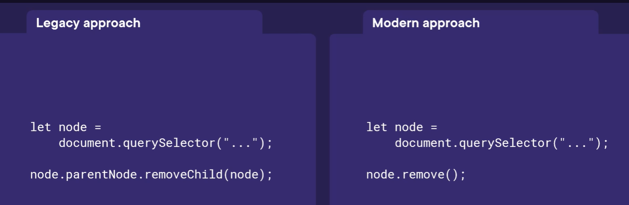

While adding an event we should use el.addEventListener() approach –

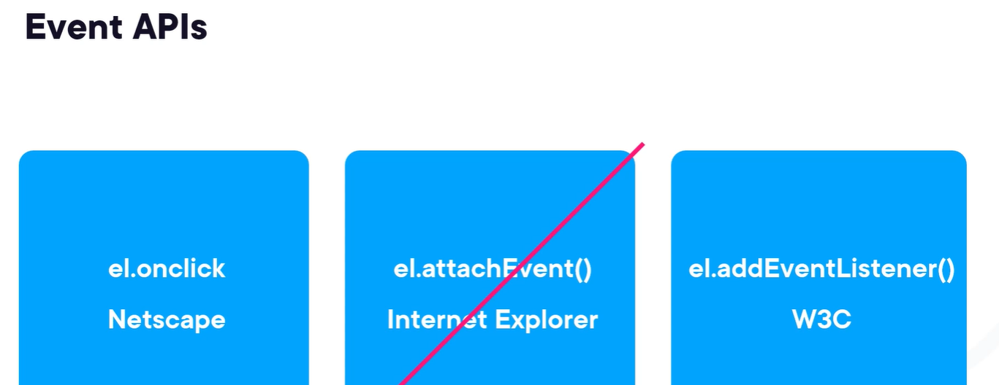

Event bubbling vs. event capturing – we should use event bubbling for event listening not the event capturing.

CSS [attribute~="value"] Selector - The [attribute~="value"] selector is used to select elements with an attribute value containing a specified word. The following example selects all elements with a title attribute that contains a space-separated list of words, one of which is "flower". The example will match elements with title="flower", title="summer flower", and title="flower new", but not title="my-flower" or title="flowers".

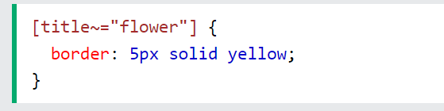

Mouse event data –

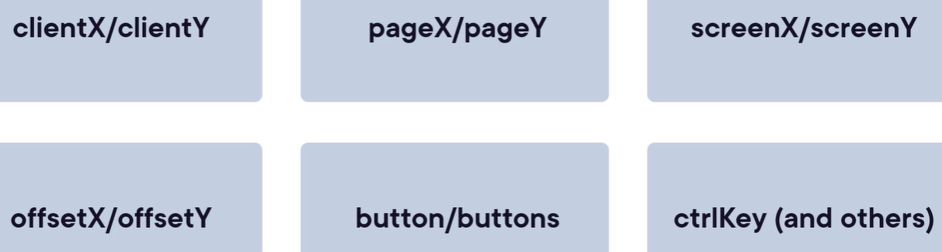

Keyboards events –



Unlike keydown, the keypress only gets fire in case of letters, digits or special characters but not for shift, ctrl, f keys or arrow keys.

We should avoid using keypress event because of browser inconsistencies, we should use keyup event or keydown event.

Keyboard event data – the code property contains string representation of the hardware key, key property is the one which we see on the text editor as a final representation, keyCode (deprecated) is the ascii code for the key that is pressed, we should use charCode property instead of keyCode to return Unicode value. We should prefer to use key property and in case of hardware specific key like ctrl, shift we should use code property.

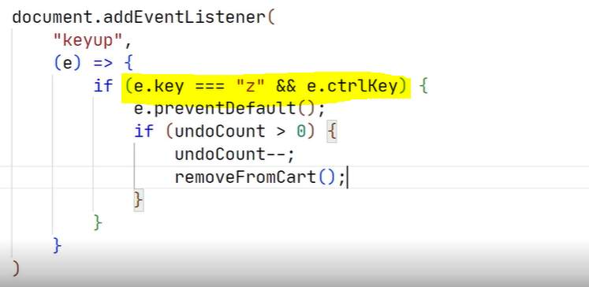

Preventing form submission –

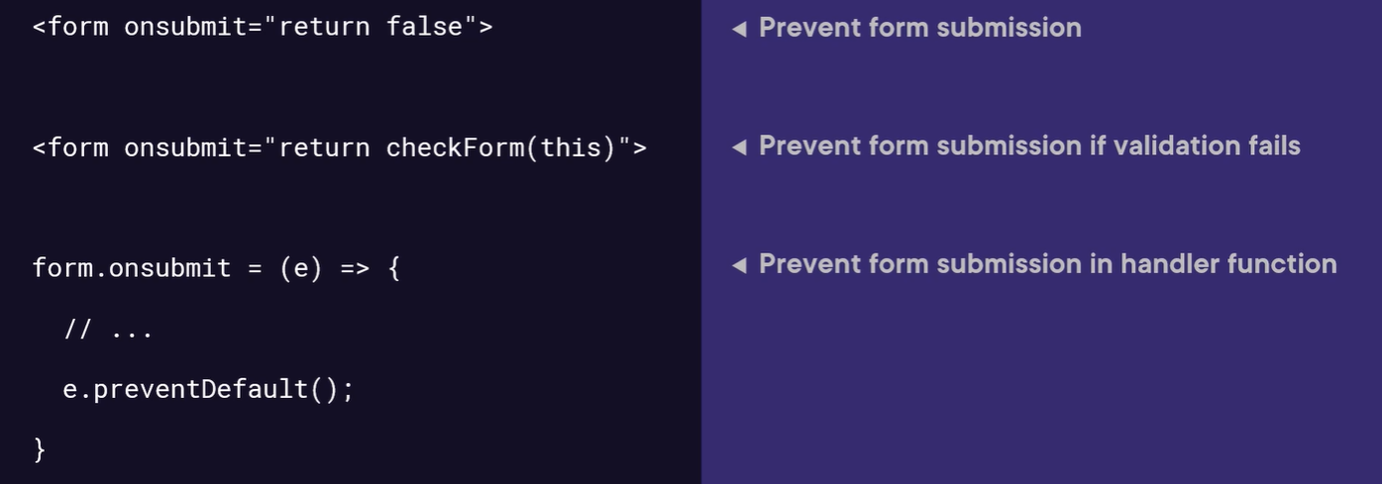

# Creating a Type Declaration File in TypeScript

Declaration files supports all the generally used module formats like CommonJS, AMD and ESM.

Declaration files are typescript files with a d.ts extension and used by the editor to provide code-completion. They are also used by the compiler to enforce correct usage.

Types – regular files that use globals (for older code) or modules that use export (ambient).

The types for the private members do not get generated as they are supposed to be used by the consuming classes.

To generate the base version of the declaration file from the JS code, we can set the below config in the tsconfig.json file then we can manually enhance it further –

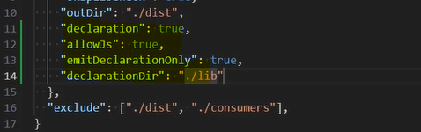

Using JSDoc with declaration file –

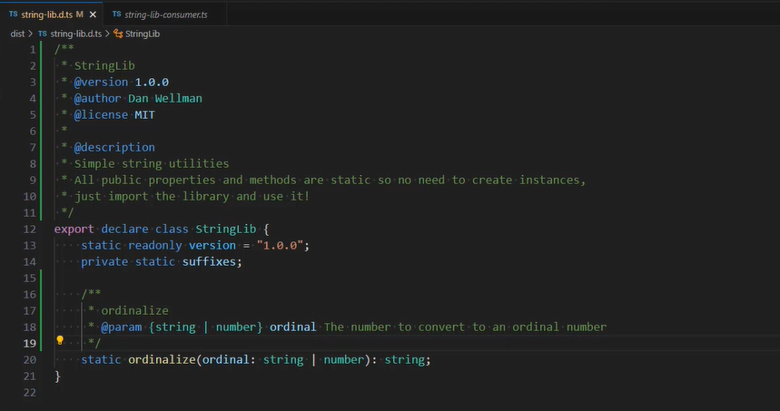

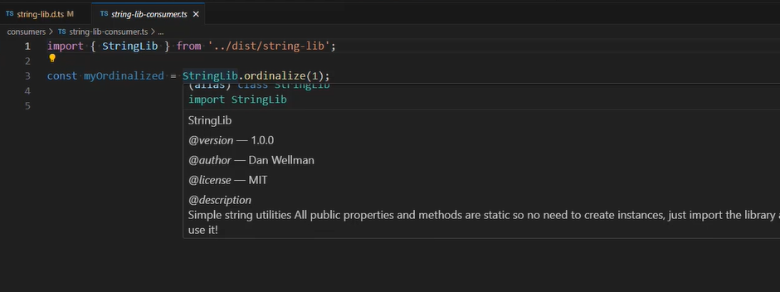

Originally there were two kinds of JS library – libraries that added a global object, e.g. jQuery, another one is libraries that extended built-in objects, e.g. Prototype. Both approaches have significant downsides as extending built-in objects in unwise in case the object changes. Global objects are convenient, but can easily be overwritten.

Instead of these both approach, we should use modular-based coding which is much safer paradigm that eliminates the worst aspects of working with globals and brings many other benefits.

Creating a declaration file for a global library – for global libraries we need to use ‘namespace’ keyword. It is not an ambient module but just an ambient declaration –

In this case the consumer directly use the Global object name which is in different folder and doesn’t import anything. To handle this, we can create the @types folder in the node_modules folder to let the IDE recognize this global type. This @types folder automatically picked up by the IDE for any third party types installation.

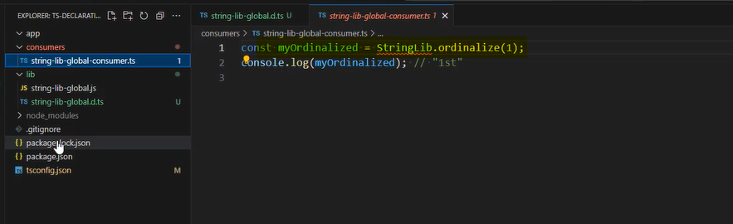

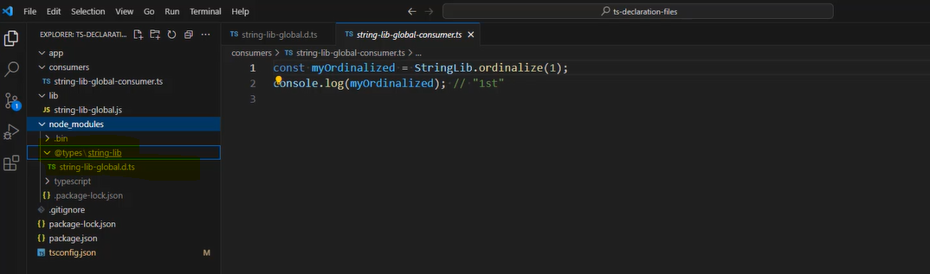

Or, we can use the triple slash directive approach by providing the relative path, but it is an older approach and not recommended one, the earlier one is recommended –

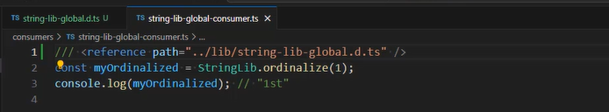

Creating a declaration file for object-extending library –

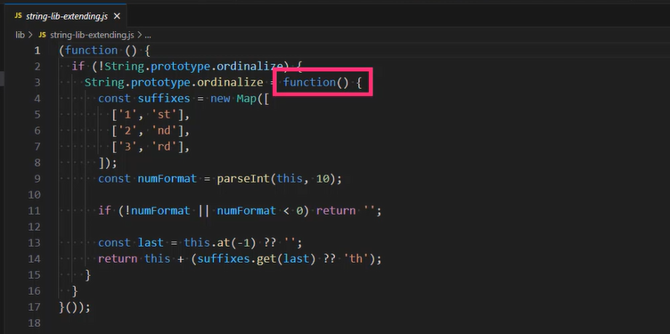

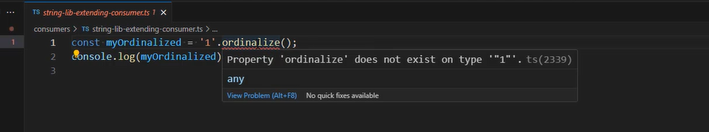

For the declaration file of this approach is a bit different as TS already have a type for String, we just need to extend it by providing definition for custom method which we added in the actual source file –

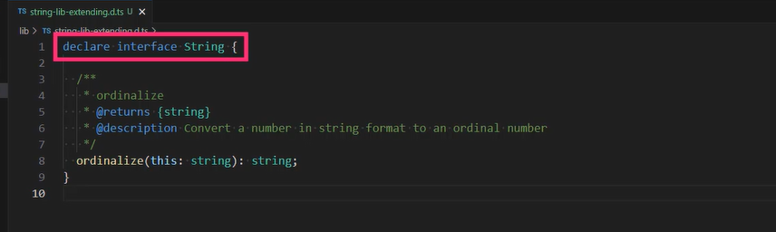

Creating a declaration file for an ESM library –

For the default export we need to write the ‘declare’ instead of ‘export’ keyword and in the last need to export the library name as default.

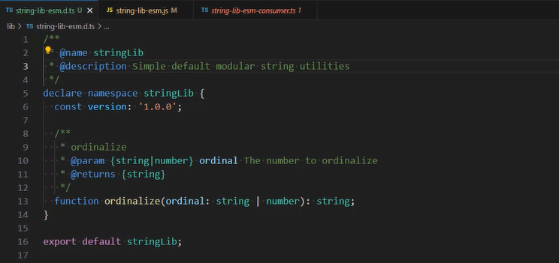

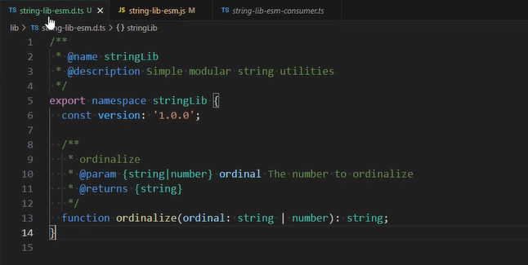

Creating a declaration file for CommonJS library –

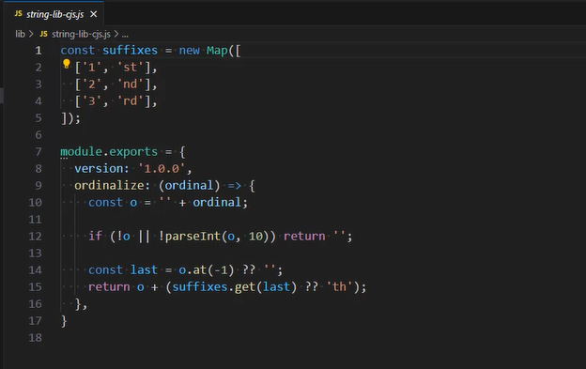

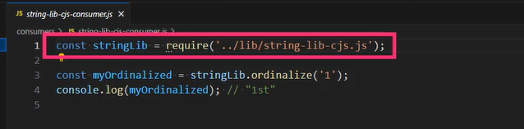

By default the TS doesn’t come with the types for Node, we need to install it explicitly by using npm install @types/node. Then only the ‘require’ will show it types otherwise it was ‘any’ –

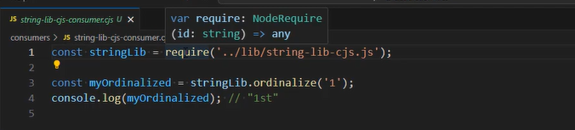

In the d.ts file we need to declare the module which is also implicitly exported –

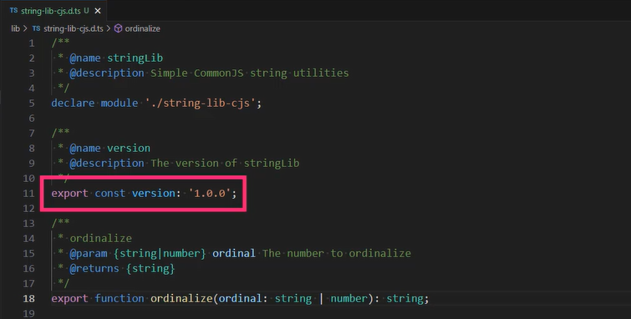

Declaration file for an AMD file –

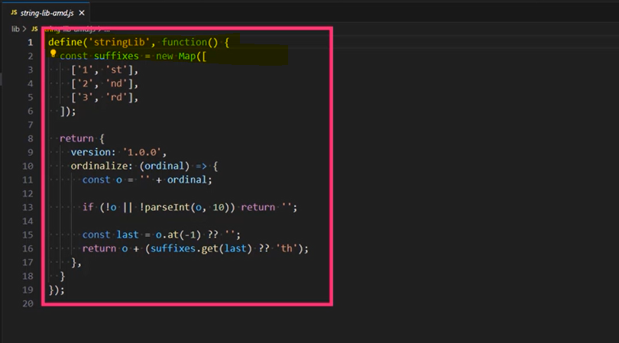

3 ways to use this AMD module –

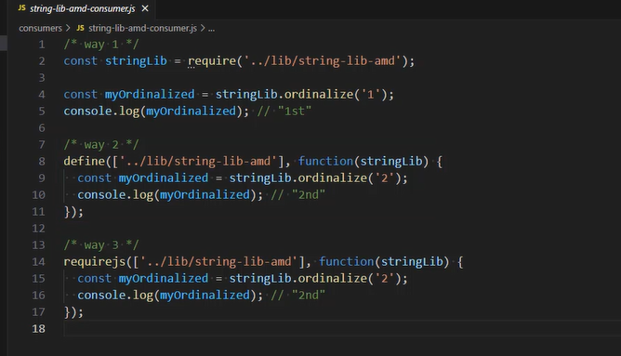

TypeScript cannot extract any type information when using the definition or requires functions to load the library as a dependency. So, way 2 and way 3 won’t show type information until we use a workaround for it.

Creating a declaration file for an UMD library – this UMD format allows to write module once and able to run it in browser and Node JS both.

The first ‘if’ to check if it is AMD module, the next ‘if else’ block check if is running in node js, the ‘else’ block means the code is running in the browser. So, this code library can run on node.js, in browsers and even web workers without any problem.

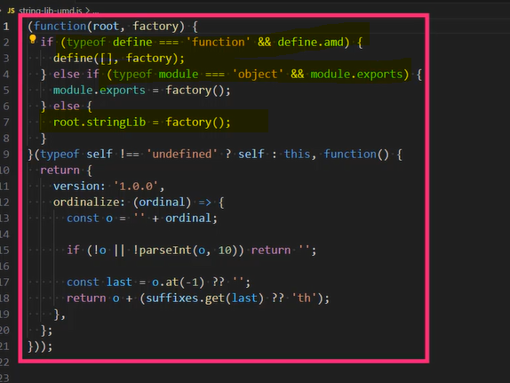

Declaration file for this format – way to consume the library –

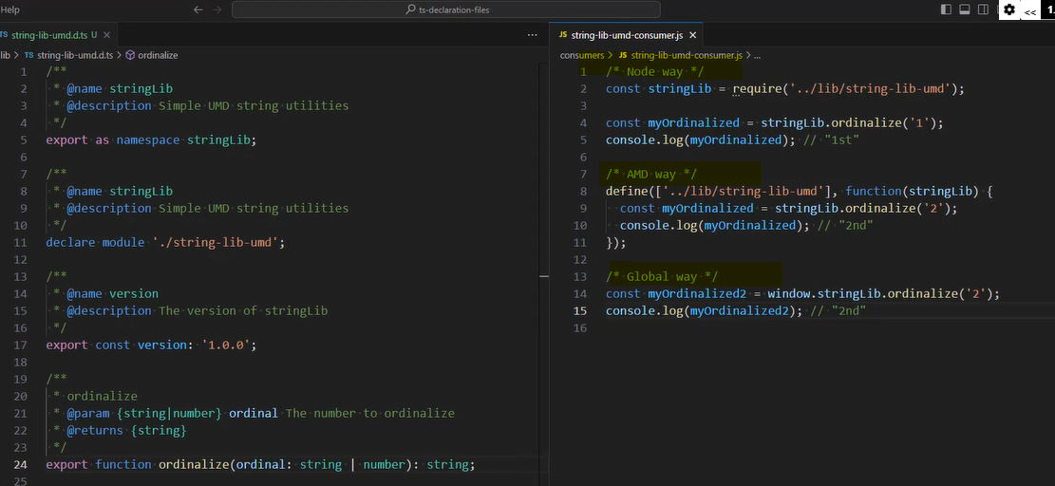

# You don't know array in javascript | PACKED vs HOLEY | JSVU | V8-debug

One of the engine on which JS run is V8. We can use JSVU (JS engine version updater)

While running the code through JSVU it will ask the engines and OS to run against –

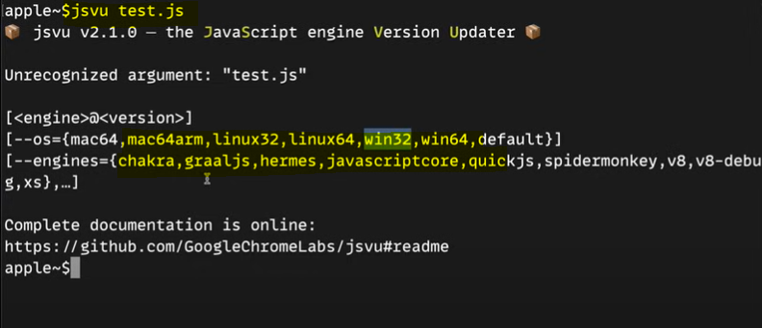

Then we print an array through %DebugPrint API it will print two properties HOLEY_SMI_ELEMENTS and PACKED_SMI_ELEMENTS.

Array Optimization types in JS - SMI (small integer), Packed element, double (float, string, function).

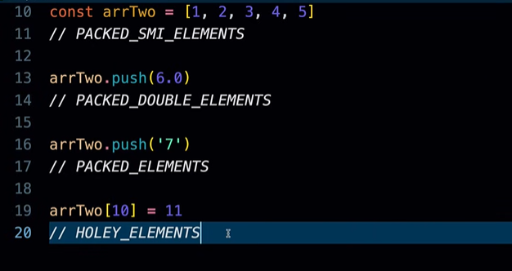

BP – terminology, while talking in terms of object we say properties of an object, in terms of an array we say elements of an array.

PACKED_SMI_ELEMENTS (continuous) means if arrays is having all values defined, HOLEY means if some values are not defined means array have holes into it.

Holes are very expensive in JS, because if we try to access a hole value, JS need to go through all the protype values to check if that property is exists or not. Due to which it is not recommended to have holes in your array –

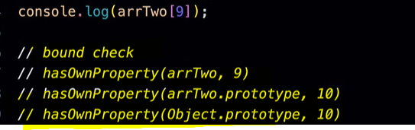

They way we write the code affects the optimization like below it is better to with second approach –

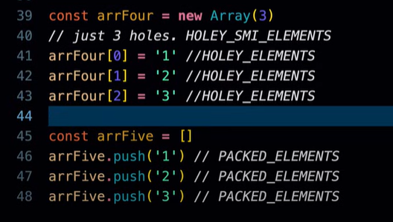

# JavaScript Performance Playbook

Best practices for improving JS performance – most of the cloud provides have CDN option as they have servers already all around the world. Modern JS frameworks already contains various best practices.

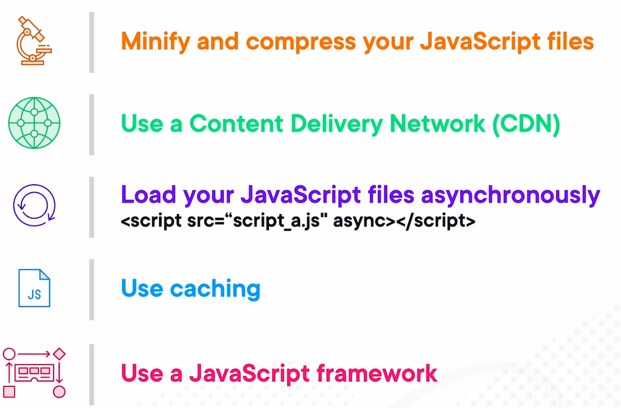

Strategies that can be used to modernize JS –

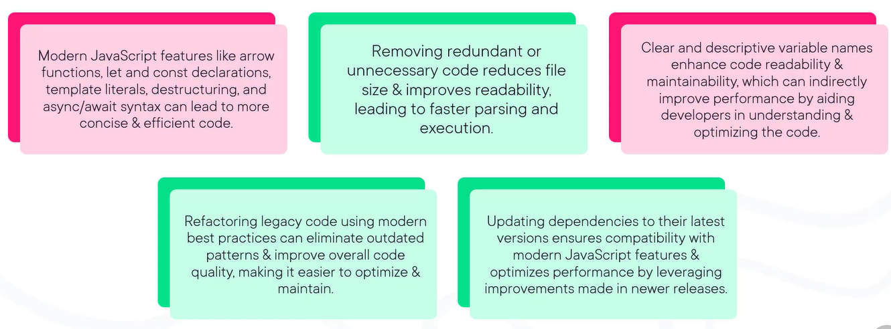

Tools for improving JS performance – for performance benchmarks, free CDN, browser dev tools performance monitor, google lighthouse.



Handling memory leak – a memory leak is when memory that is not required by an app anymore for a variety of reasons is not returned to the OS or the pool of free memory.

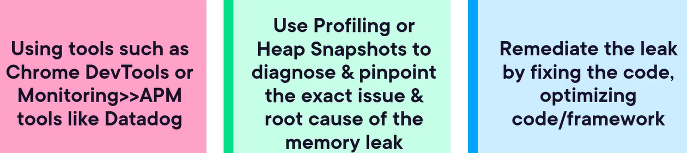

Three common JS memory leaks – forgotten timers or callbacks, accidental global variables, out of DOM references.

We need to take at-least two snapshots when application works well and when not well and then compare both the snapshot to identify the issues –

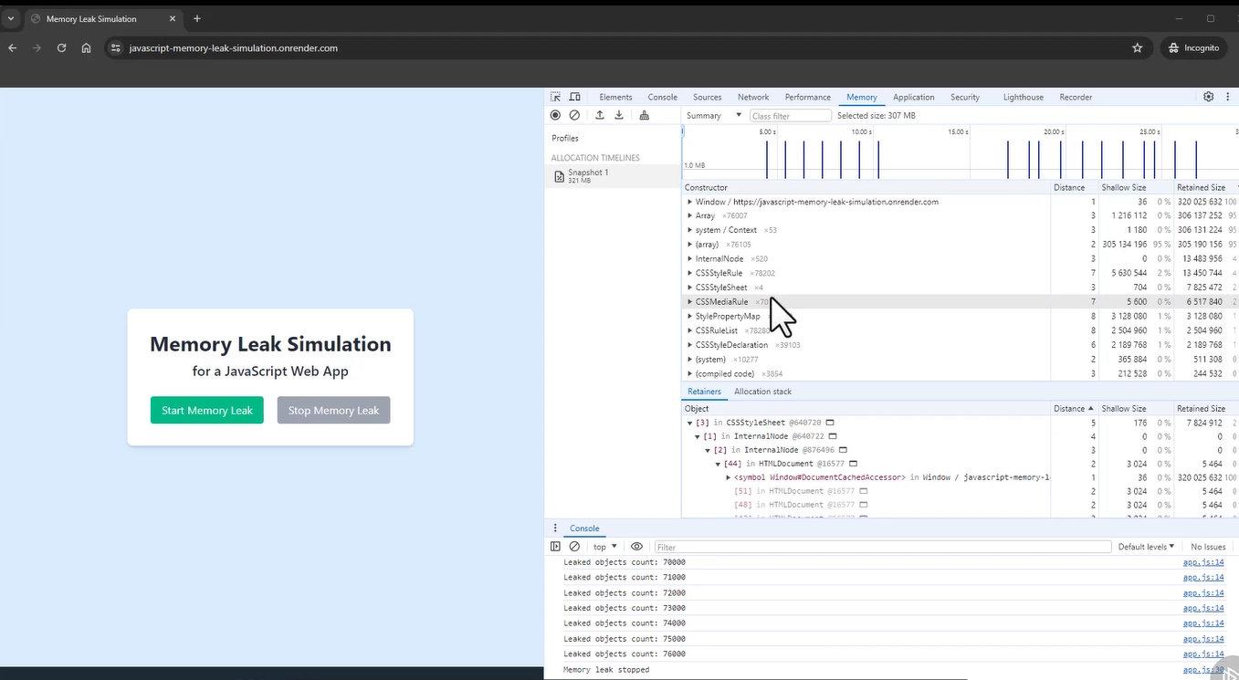

Optimizing DOM in JS – three ways to optimize DOM – minimizing searching for DOM nodes, Reduce DOM changes by grouping and reducing DOM access, size and elements as below –

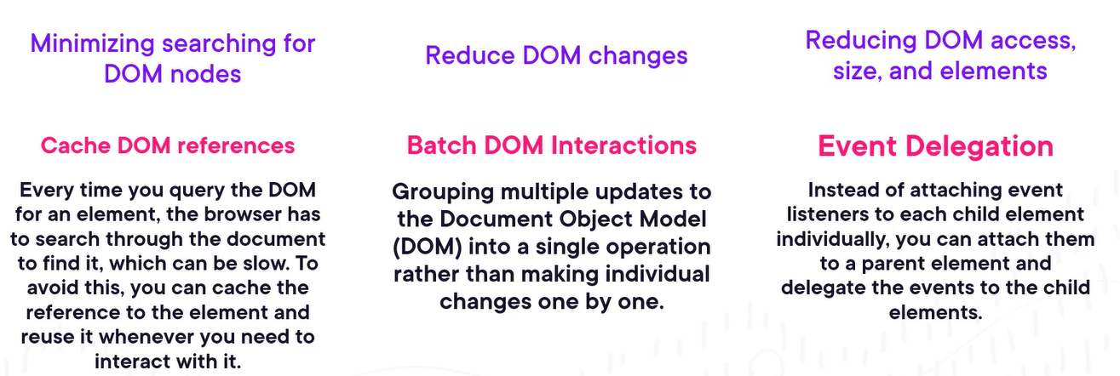

We should review our variable scope for better performance to ensure variables are not elevated beyond where they should be.

Main type of scopes in JS –



We should minimize the use of global variables to avoid conflicts and unintended side effects. Encapsulate code within functions or blocks to create local scopes, making the code more modular and maintainable.

Below operations are good candidate for async operations instead of sync – network requests (http calls), file system operations, database queries, long computations.

We can improve the JS responsiveness by using throttling JS code, debouncing JS code and reducing activity in loops.

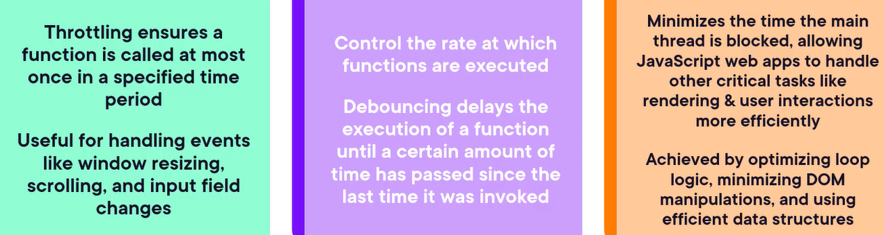

Reducing Timeouts in JS – caching objects and limiting library dependencies, delaying JS loading, using file compression.

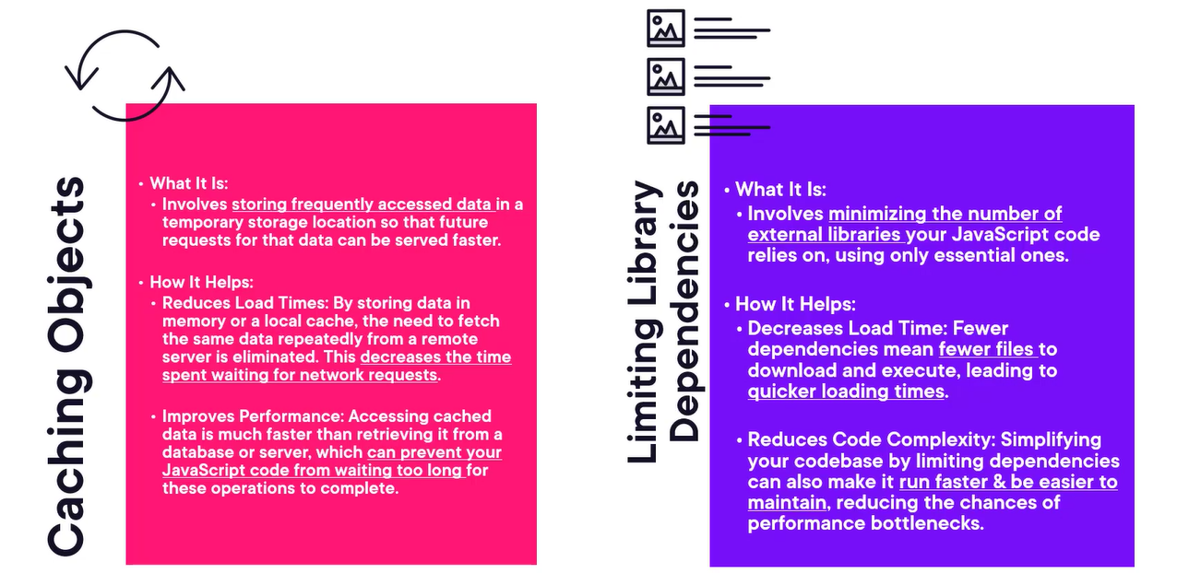

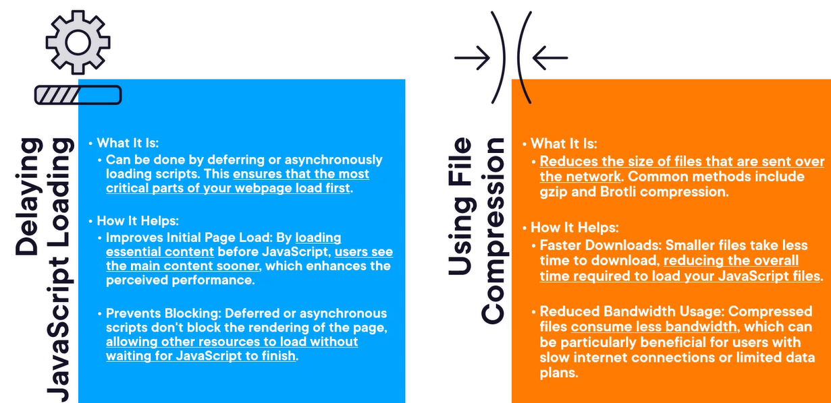

# DOM Manipulation with TypeScript

DOM manipulation means that you add, remove, and modify elements on a loaded web page. This allows us to change the page content without loading it from the server.

For DOM manipulation, TS provides types for DOM API like document and HTMLElement interface.

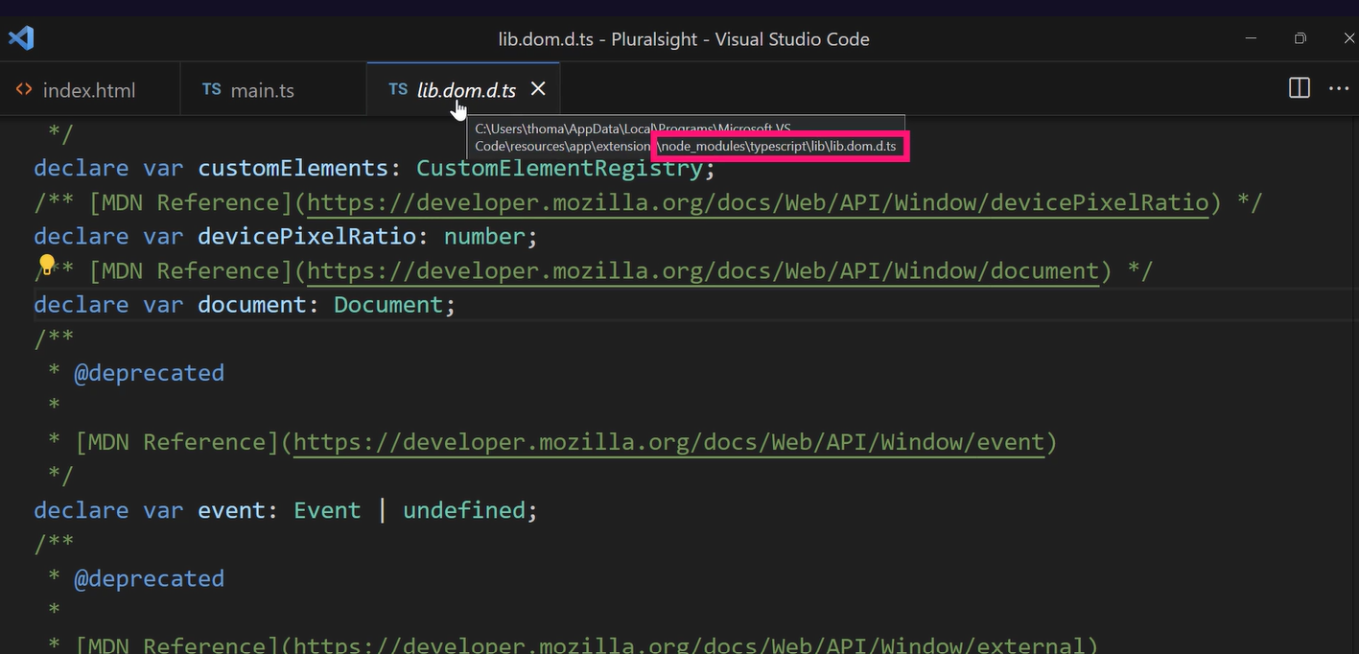

DOM is an object-oriented representation of a web page and can be manipulated by using JS.

The Document provides entry to the DOM tree of the loaded webpage and Node interface allows us to walk through the DOM tree. HTML elements are specific types of nodes in the DOM tree.

Node interface – The DOM is a tree of objects. Every object in this tree is of type node. Node extends the EventTarget interface which defines methods to add and remove event listeners.

We can use nodeType property from Node interface to identify which node type we are using like Document, Element, CharacterData, HTMLElement, Text or Comment.

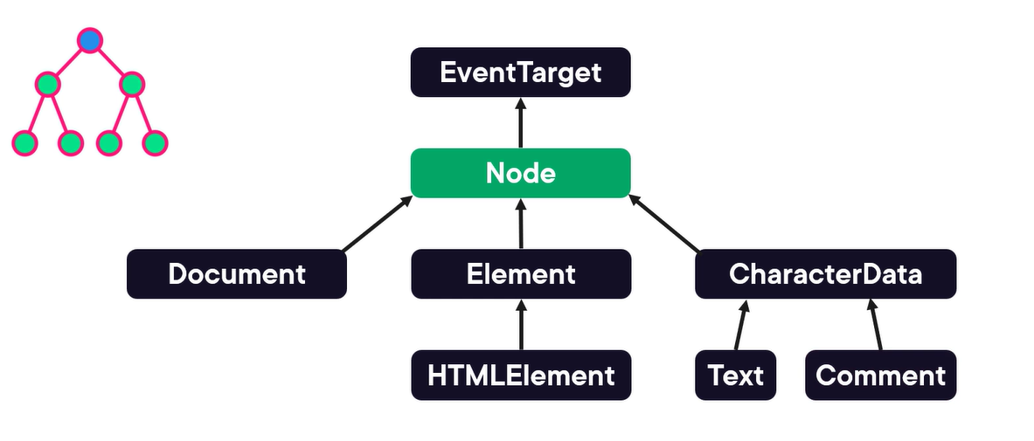

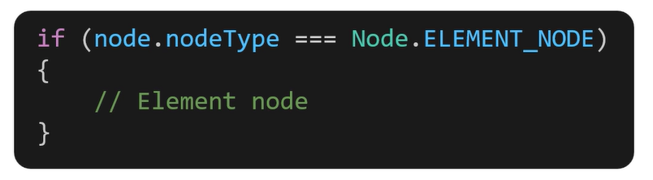

Properties of Node type – by using childNodes and parentNode we can travel up and down in the DOM tree.

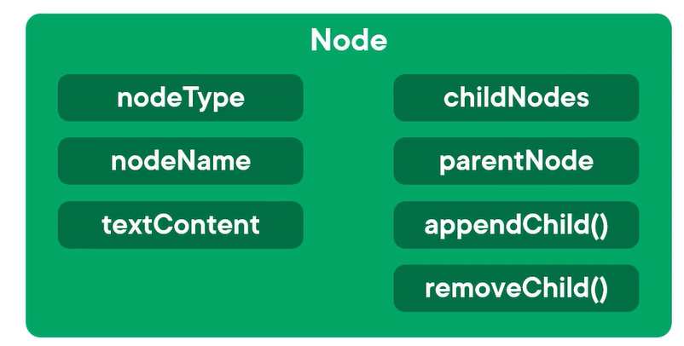

To print all the child nodes from parent instead of using a custom method with recursion, we can use the in-built createTreeWalker() method.

Different types of elements –

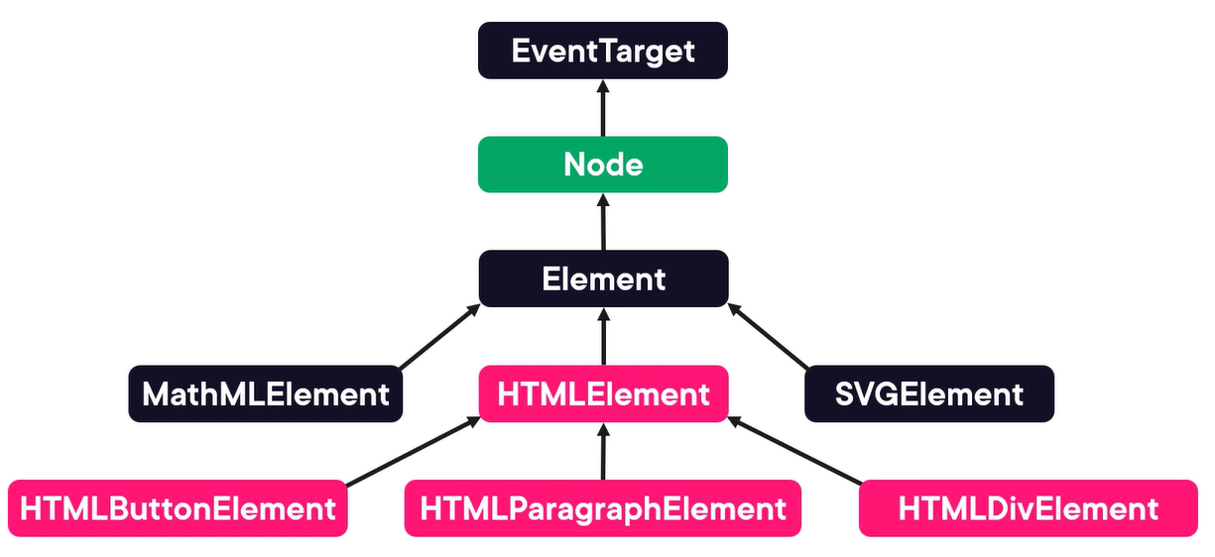

How TS maps element –

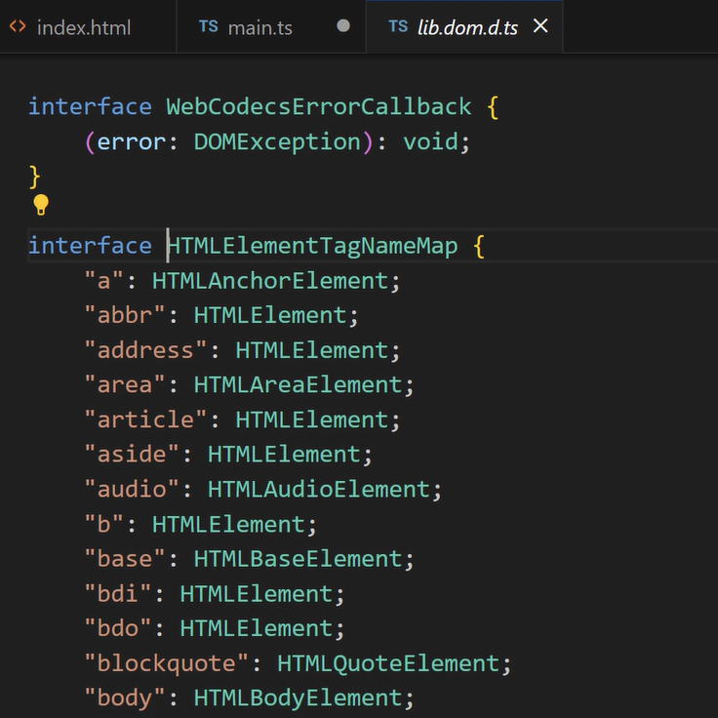

TS doesn’t know the type of element if we use dynamic value in querySelector() for which we need to explicitly tell it –

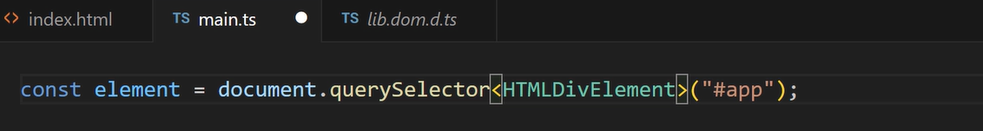

Different between childNodes vs. children property – childNodes property also returns the elements used for whitespace and comment.

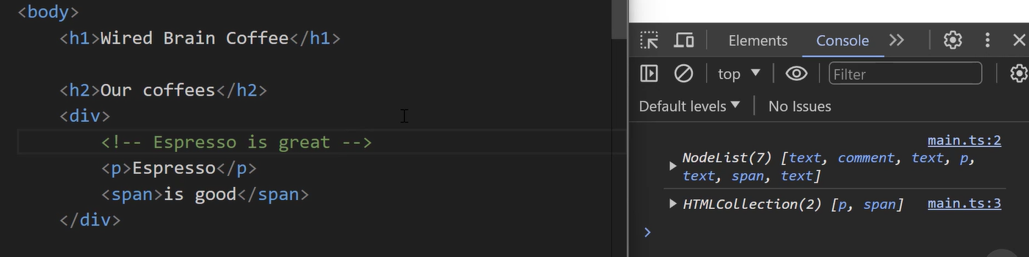

We should use modern methods instead of the older methods while selecting elements –

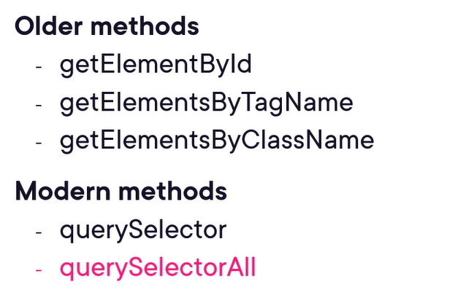

Like the same way use append() method not appendChild() method and remove() instead of removeChild(), it is more flexible then older one.

If we want to create a text node element without any HTML element, we can use createTextNode element.

Different between textContent and innerText property – the textContent property also contains whitespaces before elements. Also, if a element is hidden, then innerText property won’t log it but textContent still log that value. Ideally we should we text content property unless we have a specific scenario to use innerText property –

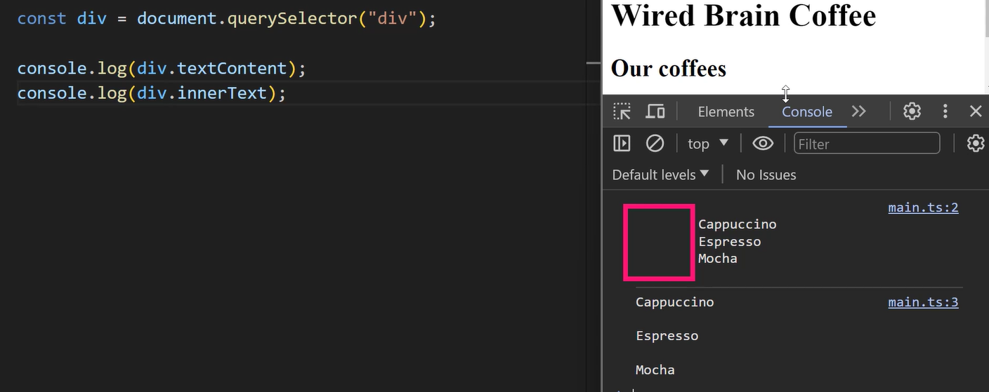

We can easily swap content using the innerHTML property for a simple scenario, but for the more complex scenario we should build components by using modern frameworks like angular or react.

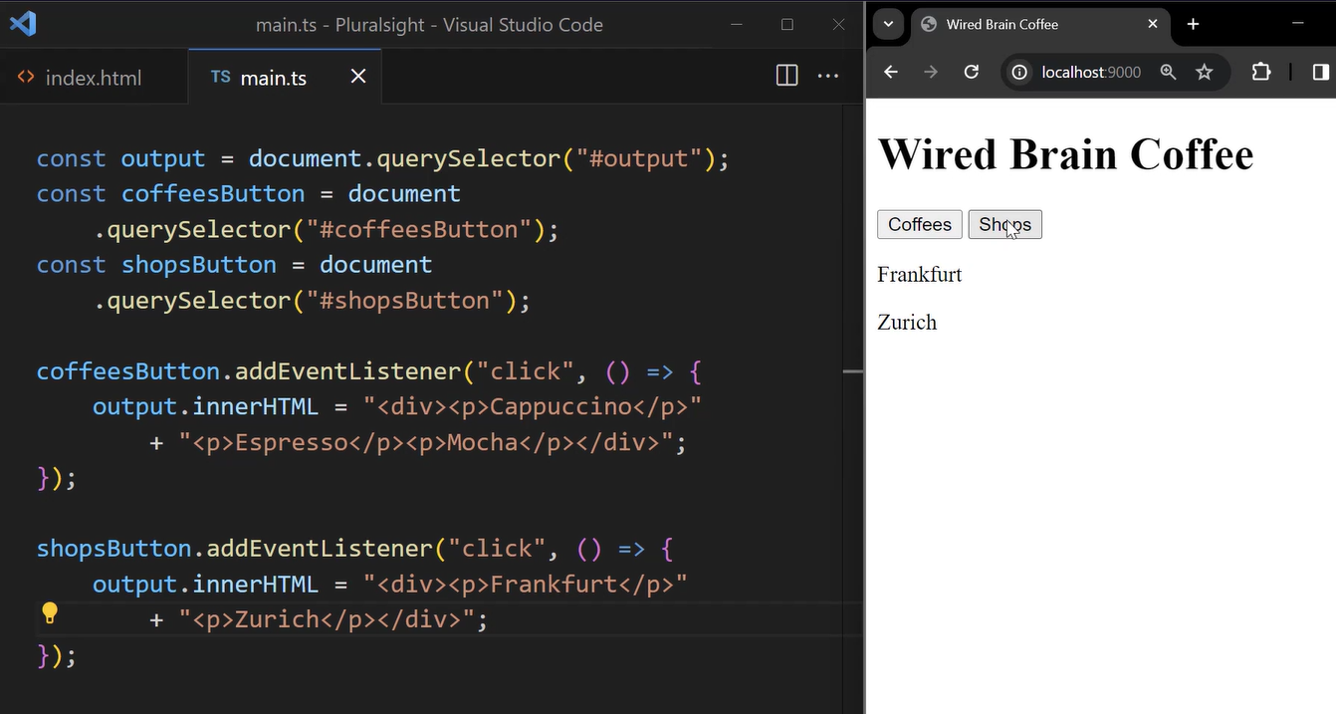

Building a custom Component without using any framework –

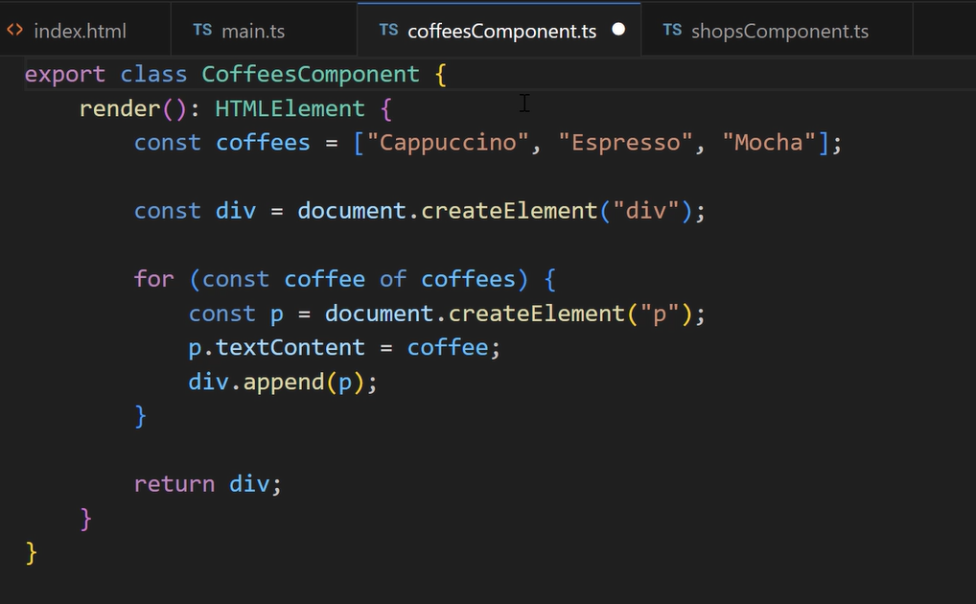

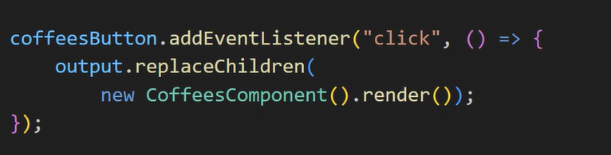

Working with styles – instead of setting the styles through the “style” property, we should not even use the className property but classList.add and classList.remove . For general attribute we can use addAttribute or removeAttribute properties.

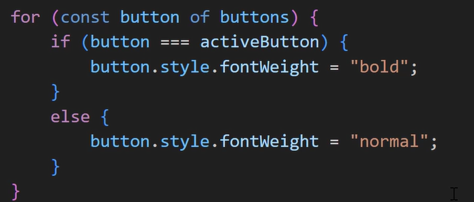

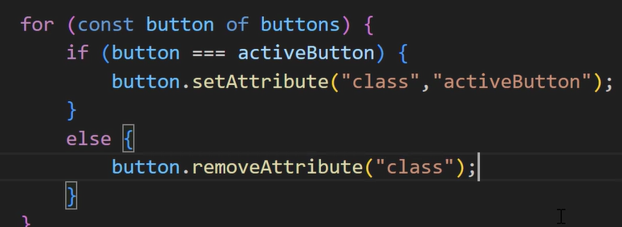

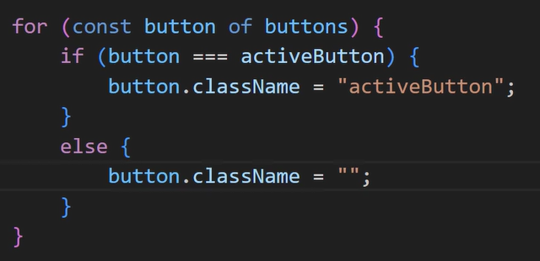

# TypeScript – Misc.

**Understanding Concurrency, Parallelism and JS**

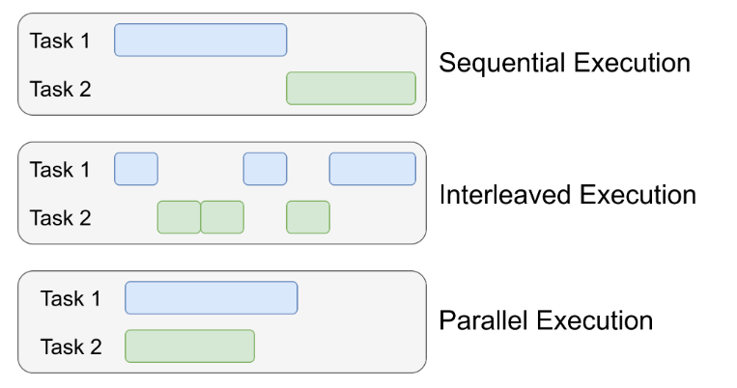

NodeJS, an Example for User-space Concurrency

Programming languages often provide their own concurrency mechanisms to simplify the complexities associated with using the Operating System’s API (system calls). This means that the compiler or interpreter can translate your high-level code into low-level system calls that the operating system understands so that you don’t have to think much.

Node.js is a great example of this concept. Although your JavaScript program runs in a single-threaded environment with a sequential execution flow, blocking tasks such as IO operations are delegated to the Node.js Worker Threads. So NodeJS uses threads behind the scenes to manage those blocking tasks, without revealing the complexities of managing them to the developer.

Here’s how it works: Blocking operations, such as writing to a file or reading from a file or sending a network request are typically handled using the built-in functions provided by Node.js. You usually pass callback functions as parameters when calling these functions, so that Node.js Worker Threads can execute the callback functions that you provided when they complete their tasks.

